Join the Revolution
Welcome to the New IFA Website! The site has been created to enhance communications with the IFA Community (students, parents, facility users and teams) and Guests.
A well as the usual features for booking training, camps and facilities, we have many new featues which allow you and your child to track performance and development, take part in coaches challenges, communicate and share your achievements with friends and family.
- Getting Started ………………………………………………………………………………….. Page 1
- Parents Dashboard ………………………………………………………………………………….. Page 2
2.1 Creating users / Adding Children ………………………………………………………………………………….. Page 2 - 16
2.2 Book Training
2.3 Book Camp
2.4 Book Pitch
2.5 Join League
2.6 Bookings
2.7 Documents
2.8 Profile
2.9 Posts
2.10 Contact Us
- IFA Player Profile ………………………………………………………………………………… Page 17 - 19
3.1 Player Info
3.2 Career
3.3 Attendance
3.4 Activities
3.5 Challenges
3.6 Stats
- IFA Social Page ………………………………………………………………………………… Page 20-27
4.1 About Me
4.2 Playing Career
4.3 Friends
4.4 Stats
4.5 Pics and Vids
4.6 Challenge
4.7 Posts

GETTING STARTED
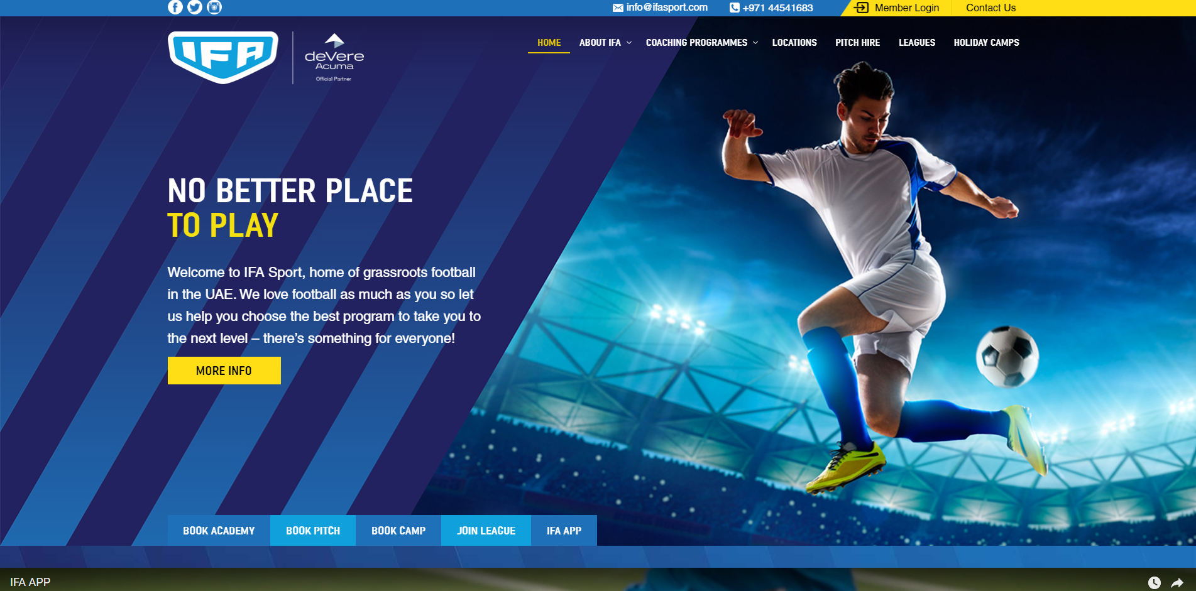
Log in to the IFA websire - www.ifasport.com
1. To become a member, register by clicking on the "Member Login" link on the upper right corner of the page.
2. For first time users, Click on the "New User" link to register or for easy access, you can log in using your facebook or google+ account.
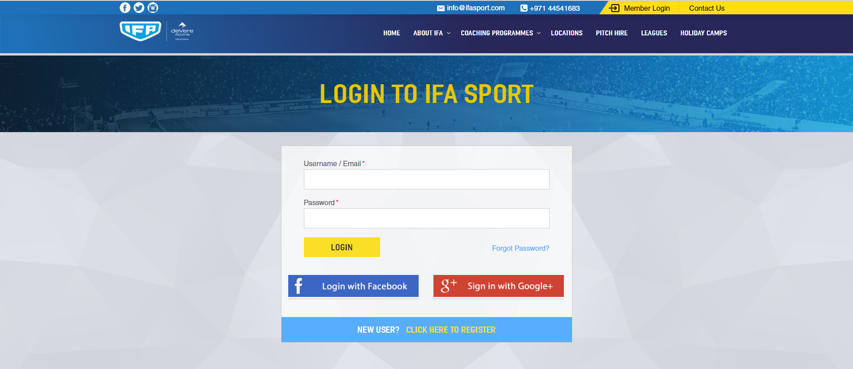

3. Complete the required details and create your own password. Click on "Register" to proceed.
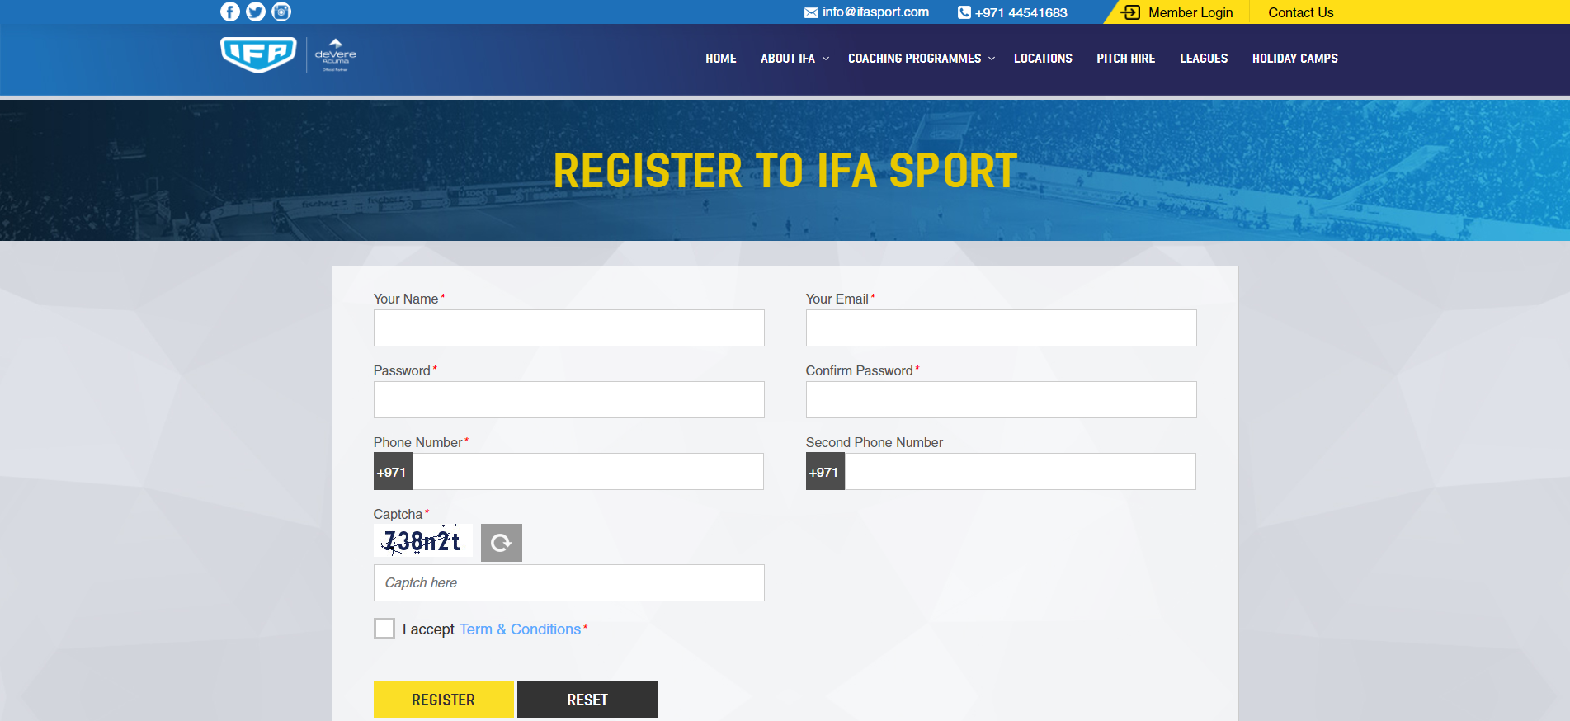

PARENTS DASHBOARD
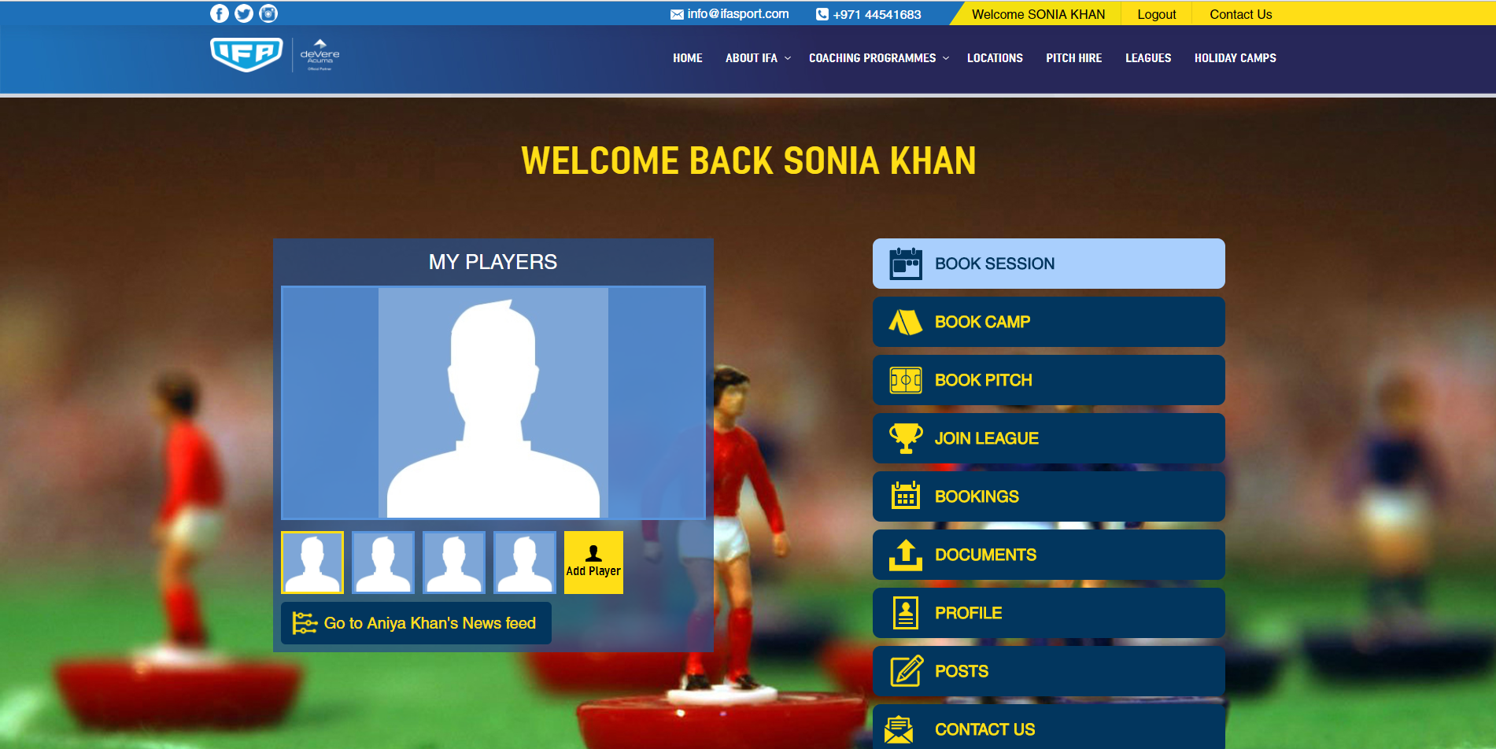
The Parents Dashboard allows you to do the following:
1. Create players (children) and view and manage your players profiles and IFA activities.
2. Book and pay for IFA programs, camps, leagues, pitch etc.
3. Allows you to view all IFA activities booked in your account
4. Allows you to upload documents required for registration in IFA programs and events

Creating Players (Children Accounts)
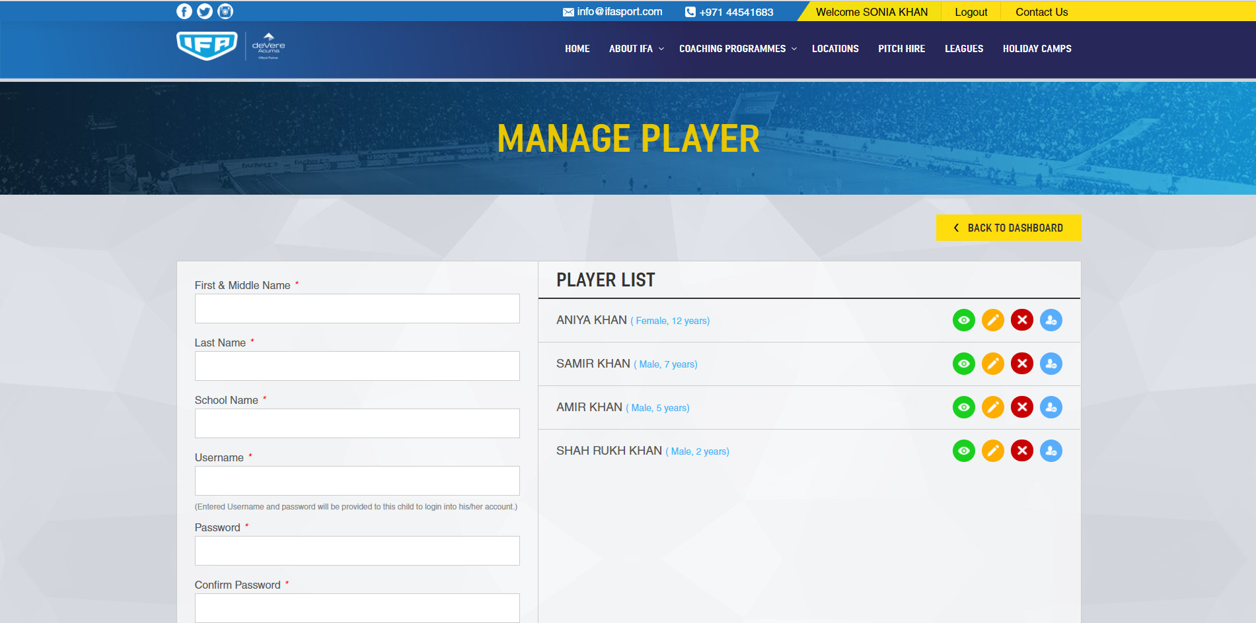
- From the Parents Dashboard, click on the link "Add Player". You will have to provide required information, as well as creating a username and password for each player registered.
- (A "private" option is given if you prefer that your players profile cannot be viewed by any of the IFA Site users)
- A summary list of the players registered will be shown on the right side. Different icons will be beside the players name as shown below:
Clicking on one of the icons will let you do the ff:
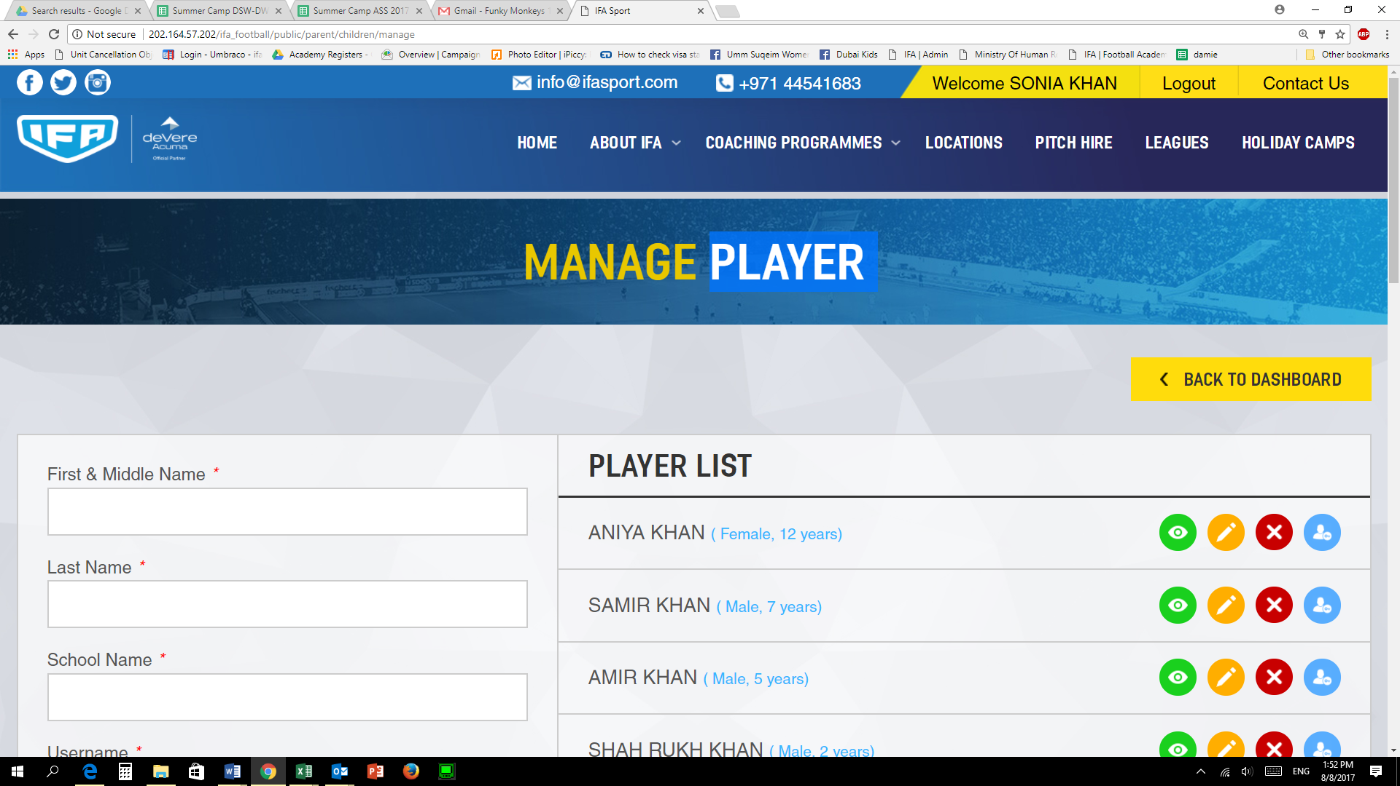 View player’s profile
Edit player’s profile
Delete player’s Account
Log in using player’s account (If your child is too young to use the features)
Once a child or user has been registered, it will create an IFA social page for them which will allow them to create posts, share photos/videos etc. Parents will be notified and will have to approve posts. For added security we will automatically scan and detect “text” that’s is inappropriate so that these cannot be posted.

Book Training

Parents can easily book and pay for sessions using the IFA Website by logging into their account. To book sessions:

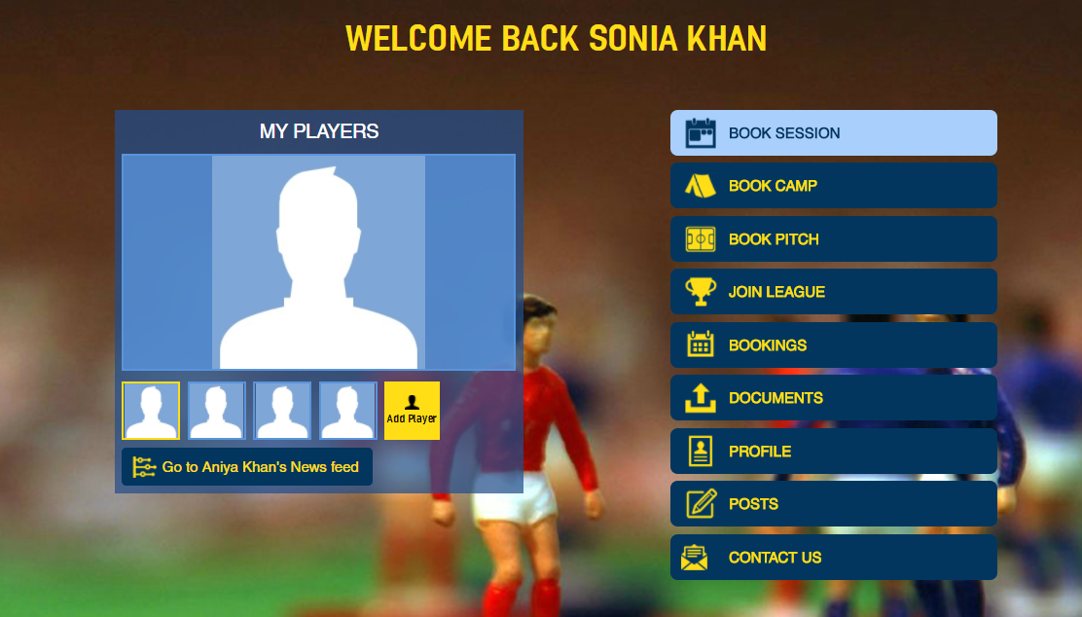
From the Main Parents Dashboard, click on “Book Session"-
Available program locations will be displayed. Location can be viewed by list or as pins on map.
You can change the view by clicking on the icons right hand corner above the list or map.

List View
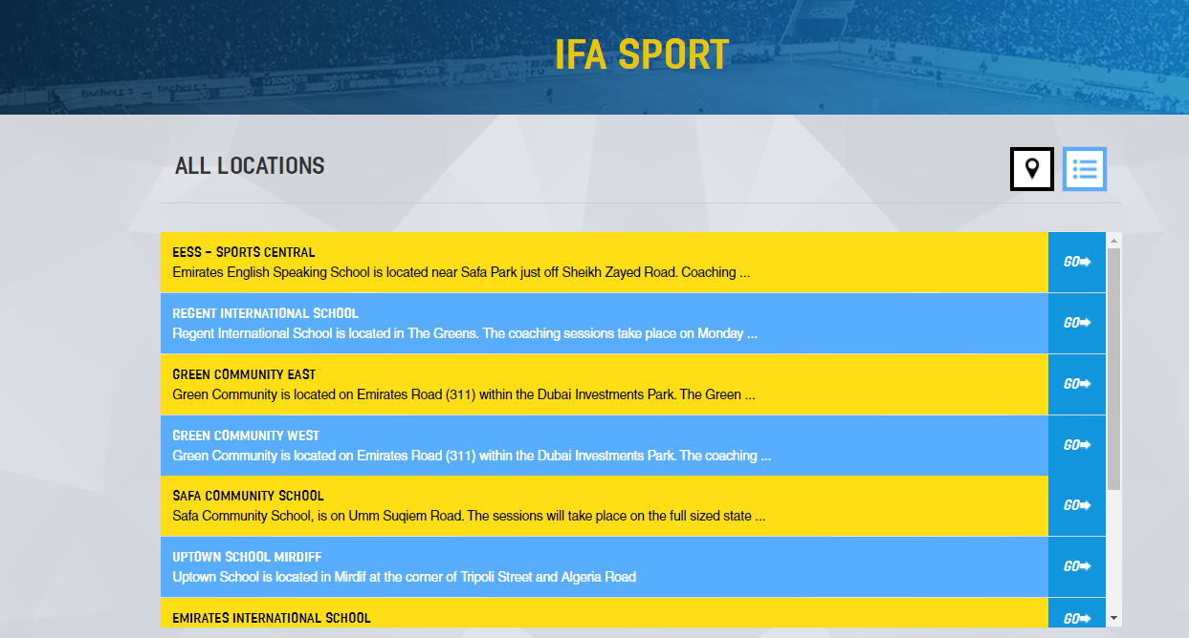

- On the list view, you can select the venue and click on "Go" to view the available sessions
- Select the day, session and age group you would like to book by clicking “Book"
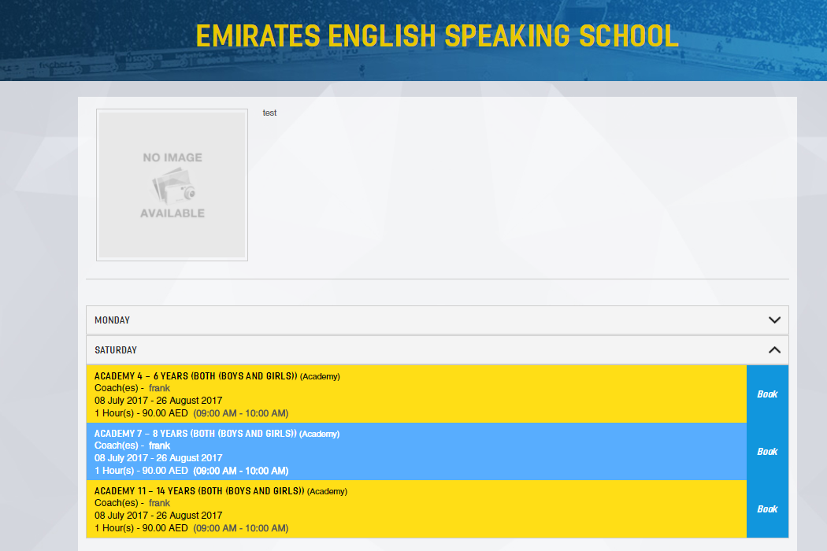

- Select the Child based on the age group you have selected.

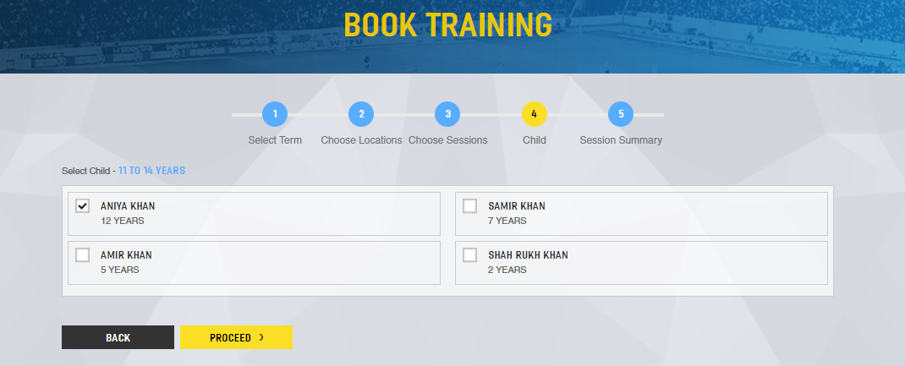

- Summary of the session and payment will be shown. To book for more sessions or child, click "Book More Session"
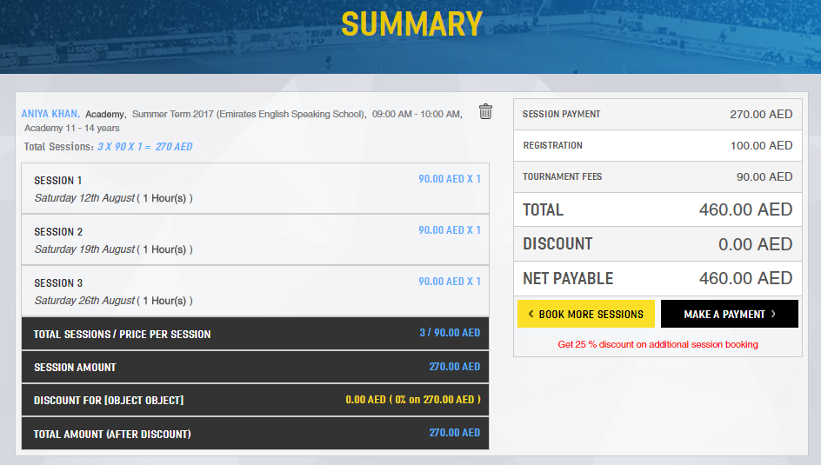

- Once booking is completed, click on “Make a Payment", page will direct you to a secure payment portal. . If for any reason you do not want to continue with boking this session you can delete it using the icon.

- Provide required information, once payment has been completed, an online receipt will be sent to the email address you have provided.

Map View
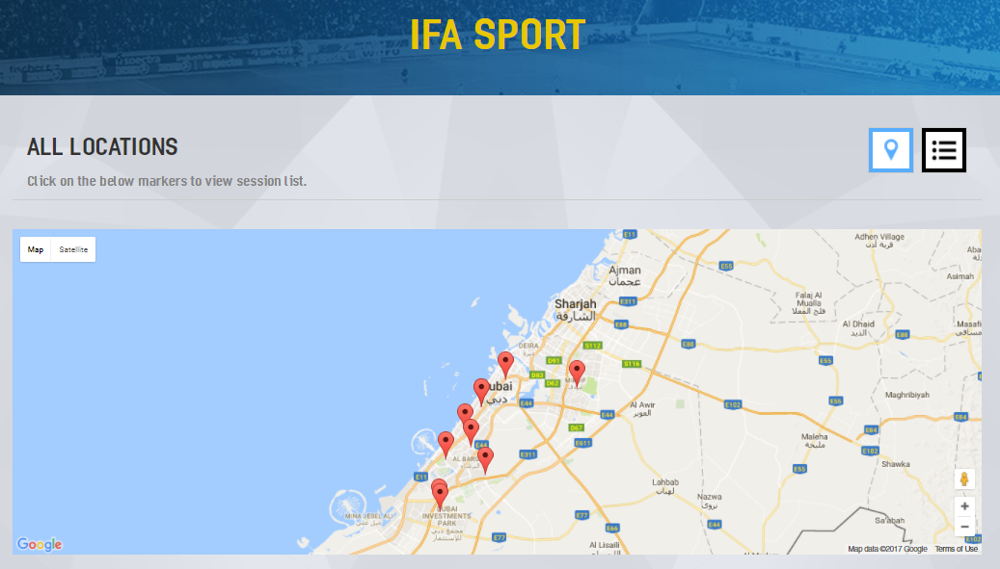
On the Map view, you can select the venue by clicking on the Map Pin and click on "Go" to view the available sessions
Select the session you would like to book by clicking “Book"
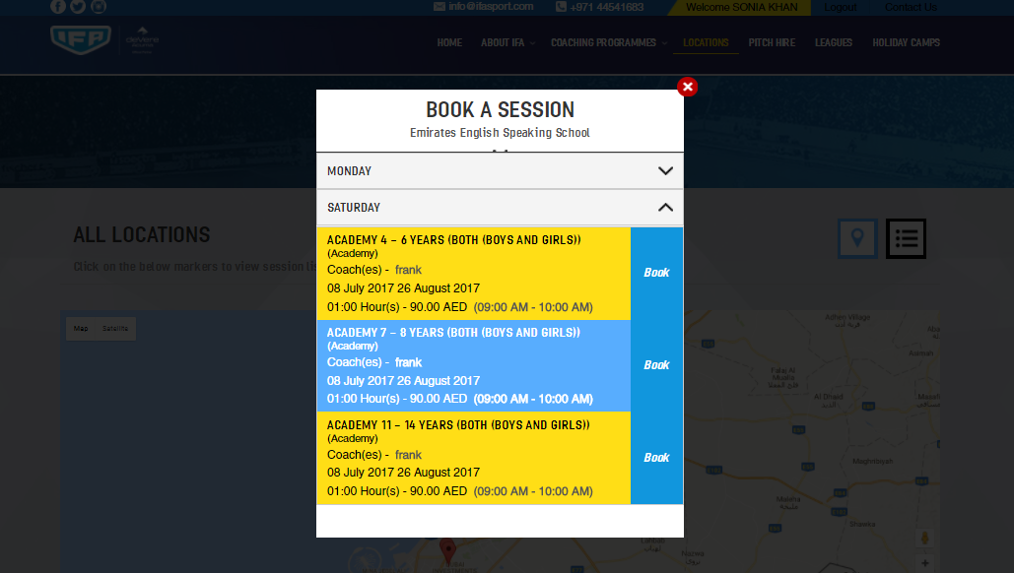
- Select the Child you would like to book for the session.
- Summary of the session and payment will be shown. To book for more sessions or child, click "Book More Session"
- Once booking is completed, click on “Make a Payment", page will direct you to a secure payment portal. If for any reason you do not want to continue with boking this session you can delete it using the icon.
- provide required information, once payment has been completed, an online receipt will be sent to the email address you have provided.

Book Camp
Different camps will be offered throughout the year. Parents will be able to get information, book and pay. To book camps:
- From the Main Parents Dashboard, click on “Book Camp"
- Page will be directed to the list of venues and camps available, Select venue and click “Book Now”
- Detail of the camp and map will be shown, to continue, click “Book Now”
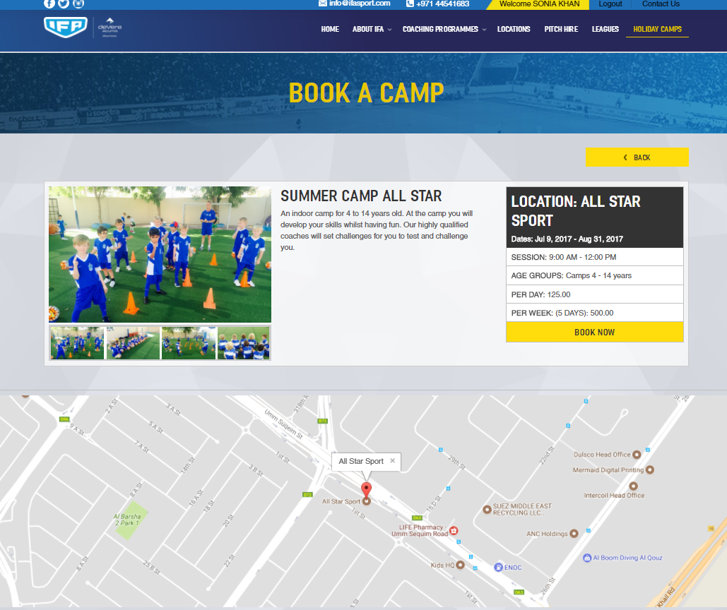
- Select the day or week to book
- Select the kids to book. Multiple kids can be booked at the same time and schedule can be customized for each child.
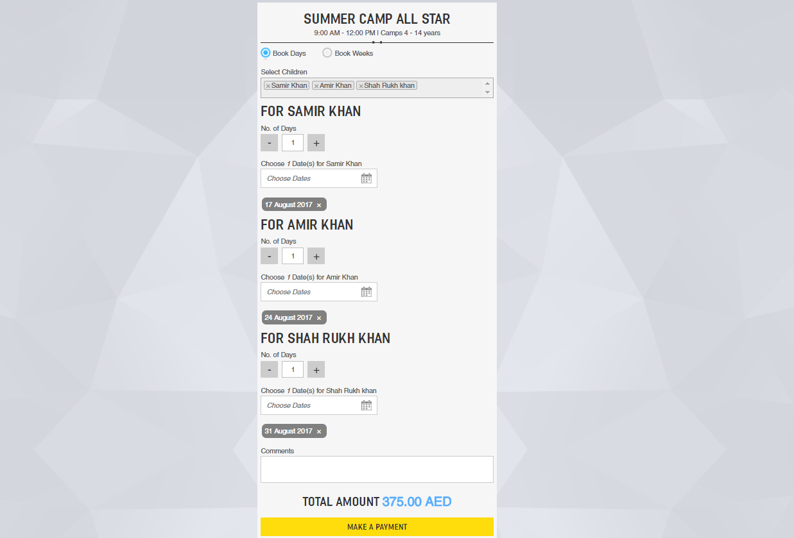

- Once booking is completed, click on “Make a Payment", page will direct you to a secure payment portal.
- Provide required information, once payment has been completed, an online receipt will be sent to the email address you have provided.

Book Pitch

- Information about pitch availability and schedule will be viewed by clicking “Book Pitch”
- Page will be directed to available venues, select location and click “Book Now”
- Select Type of booking, Size and schedule you would like to book. Click on “Continue”
- On selecting “Single” booking type, enter the date that you require a booking for and then click on “check availability” this will show you available slots for selected date then click on the slot you require. If there is no availability, you will be shown alternative dates. On selecting “Continue” you will also be shown available slots for that time over the next four weeks which you can select.
- If you select “Multiple” booking type, enter the date range that you wish to book the pitch. All the days of the week will be shown so if for example you only wish to play on a Monday and Sunday deselect the other days. Click on “Check Availability” and choose the time slots that are available.
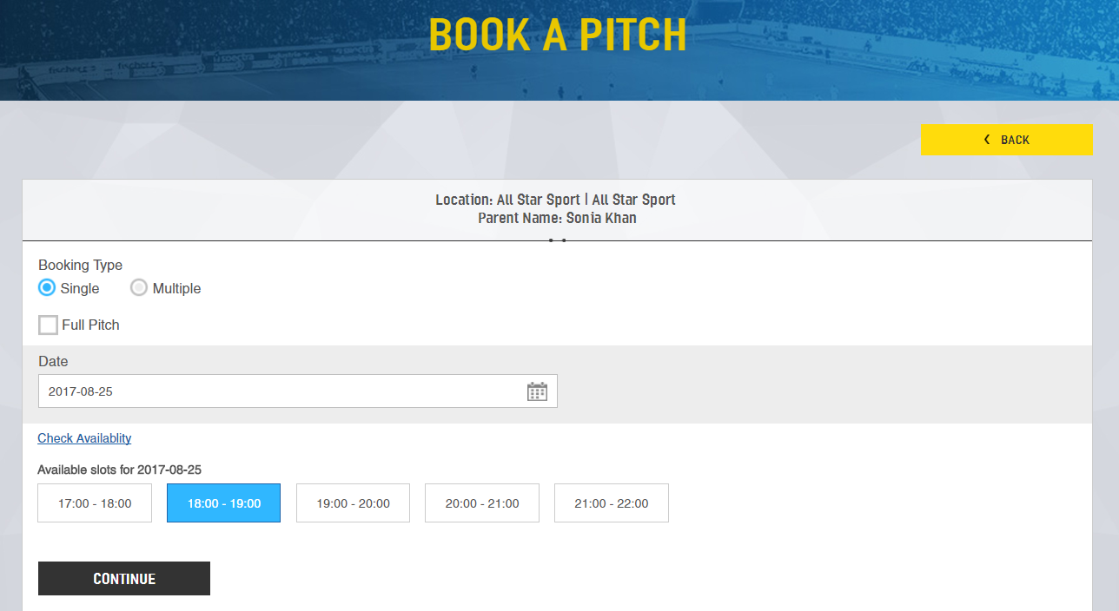

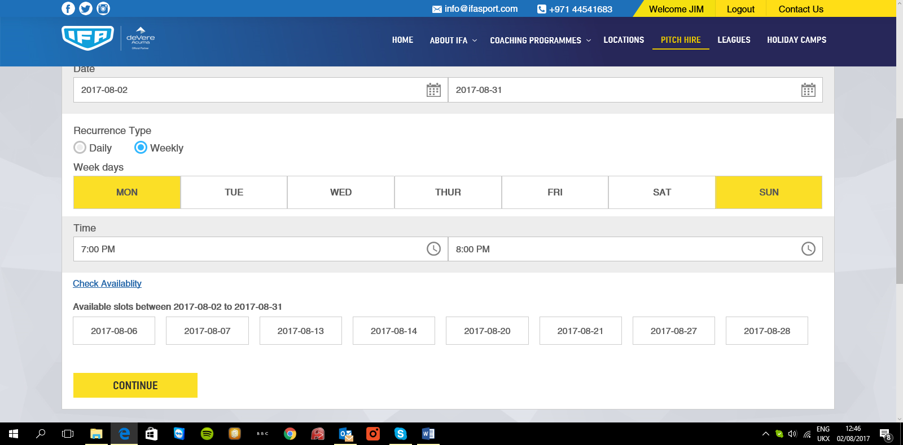

- Summary of your booking details will be shown, click on “Book More” to add more bookings
- Once booking is completed, click on “Make a Payment". A pop-up reminder of the cancellation fee will show, click “OK”. Page will direct you to a secure payment portal.
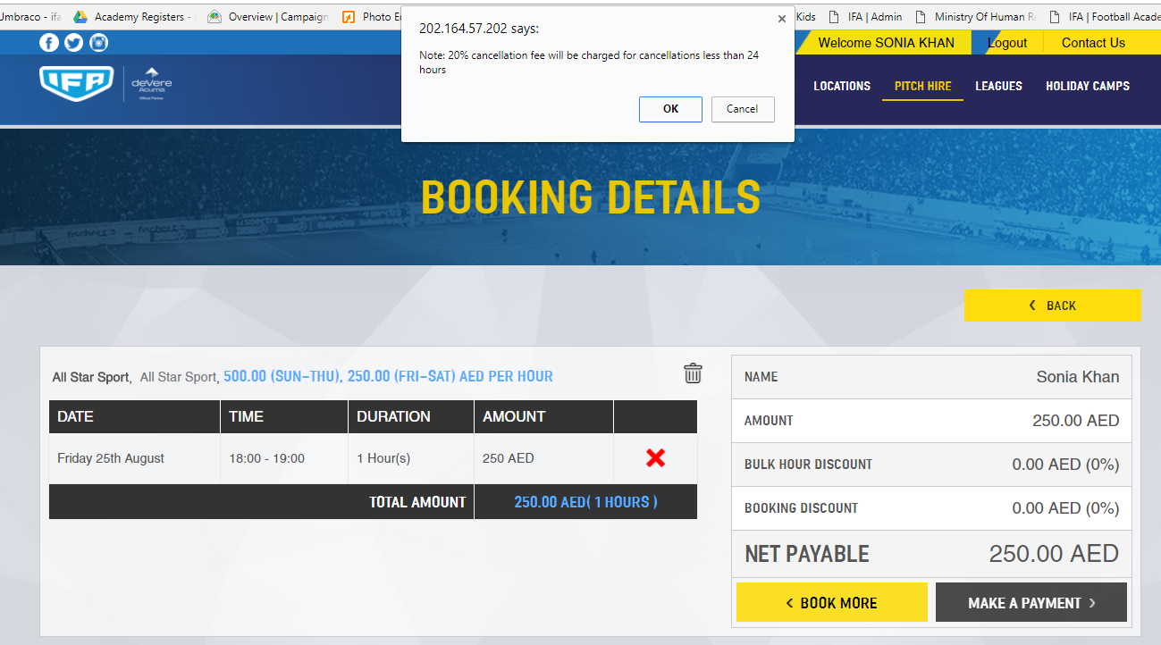
- Provide required information, once payment has been completed, an online receipt will be sent to the email address you have provided.

Join League
Information about leagues can be viewed on site. Details about type of leagues, schedule and registration information will be available on this page. To enquire re-joining one of our leagues. Select the league that you are interested in joining and then fill in the simple contact form.

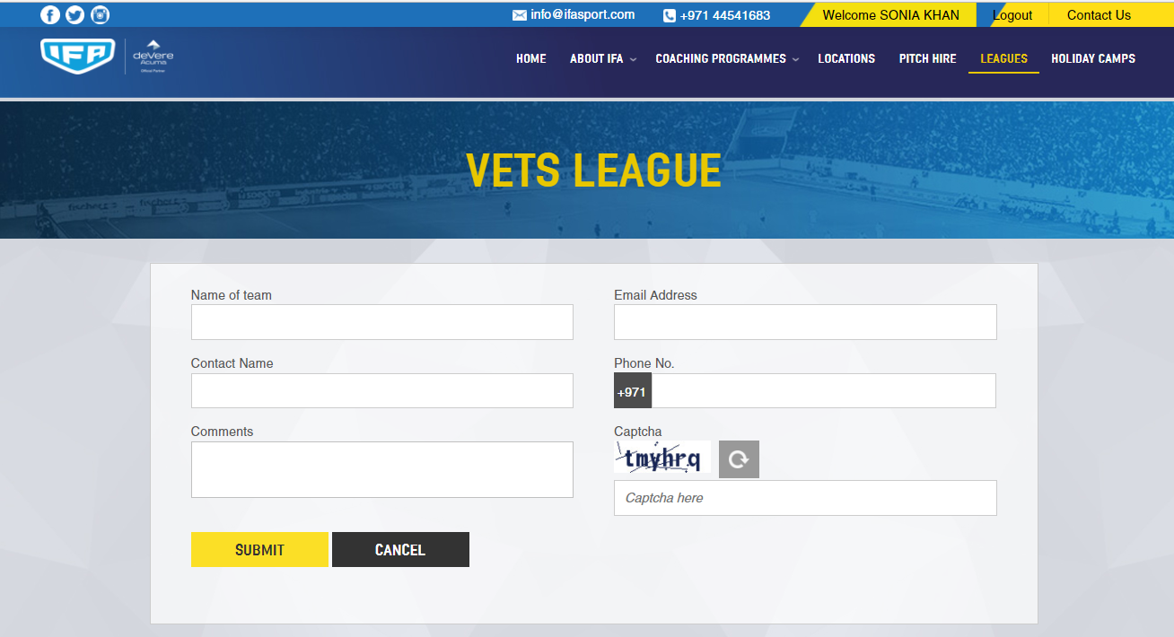

Bookings
This is a history of all bookings made with IFA. To view the detail click on the icon.
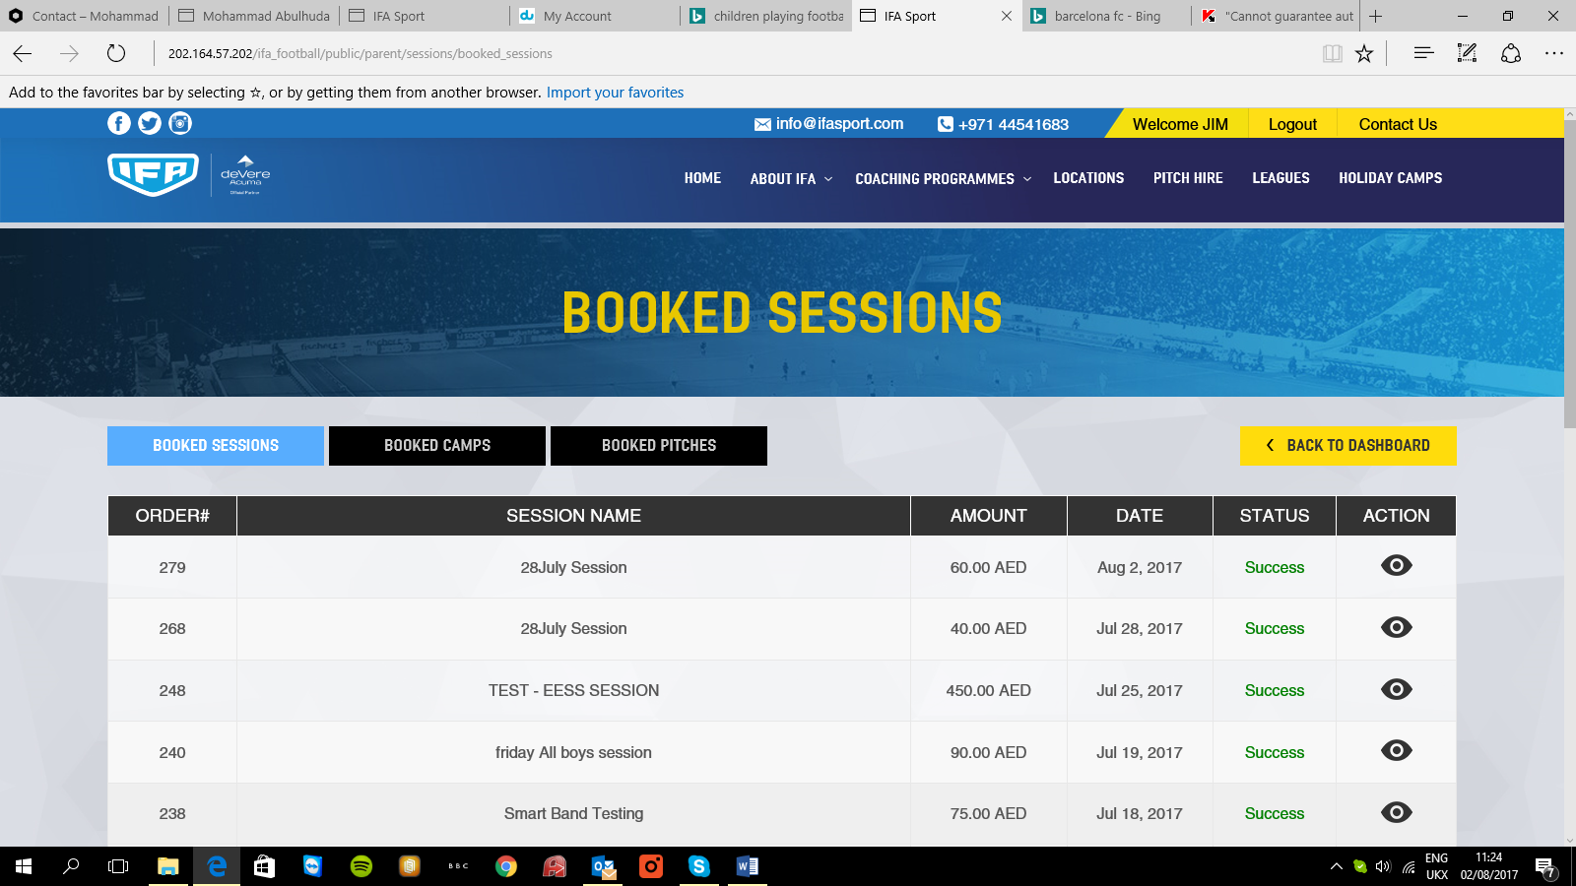

Documents
From here you can upload documents for us or see documents that the coach has sent to you.

To upload documents, add title, attach the documents and select the person that you wish the document to be sent to. You can also add comments.
You can also view and delete documents from here.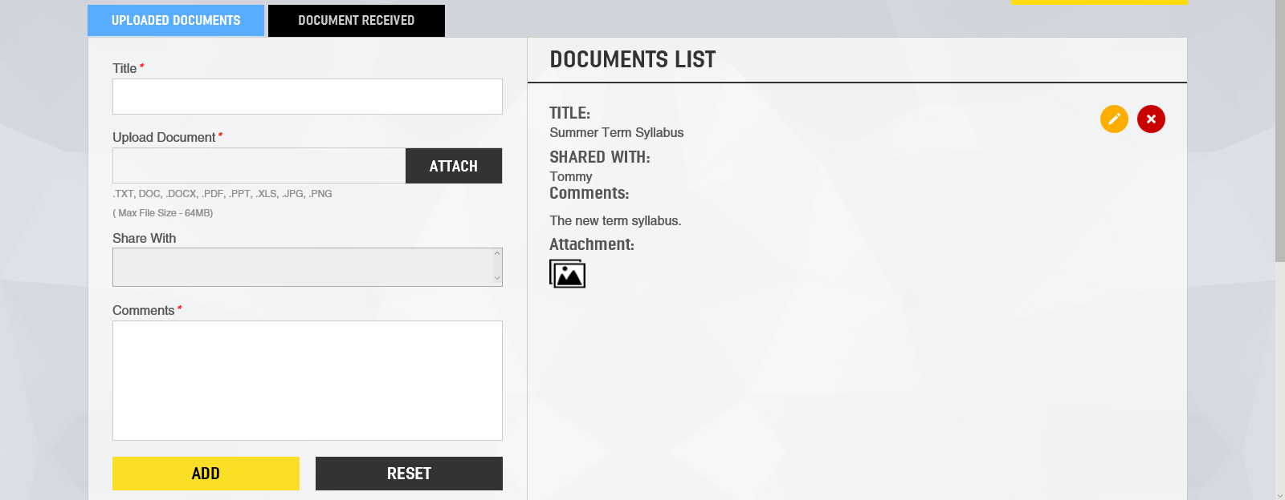

Profile
Update your profile picture by clicking on the camera icon, update your contact details and request a password change.

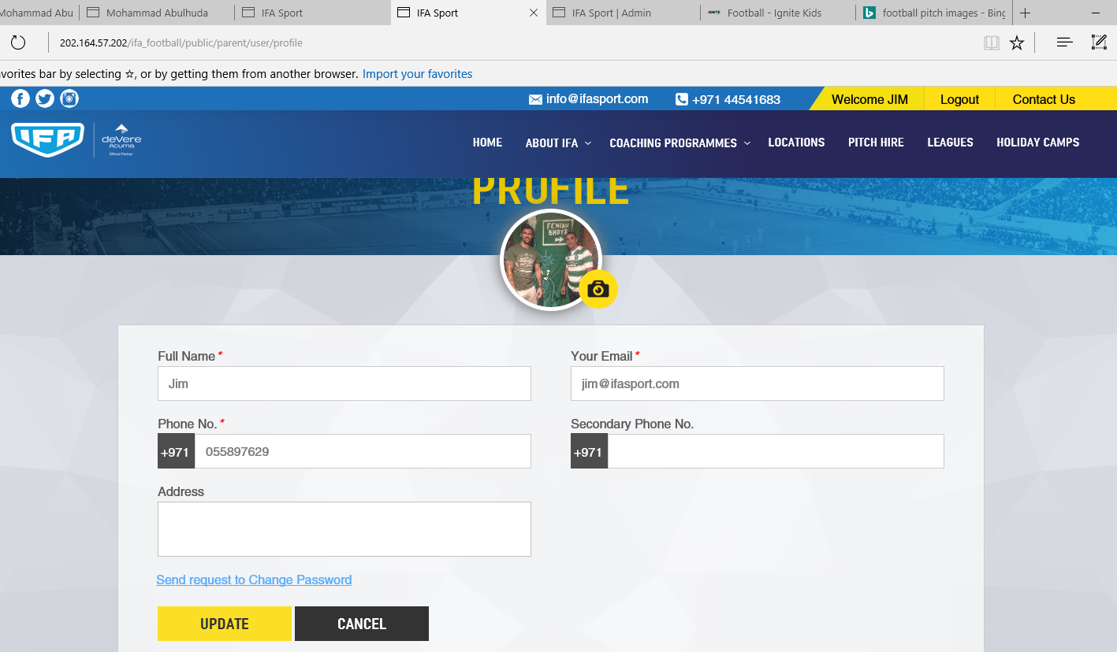

Posts
Allows you see all posts that your child(ren) have created and received. You can approve posts of your children by clicking on the  icon. Once approved these will be shown and shared on your player’s newsfeed. You can also delete posts by clicking on the icon.

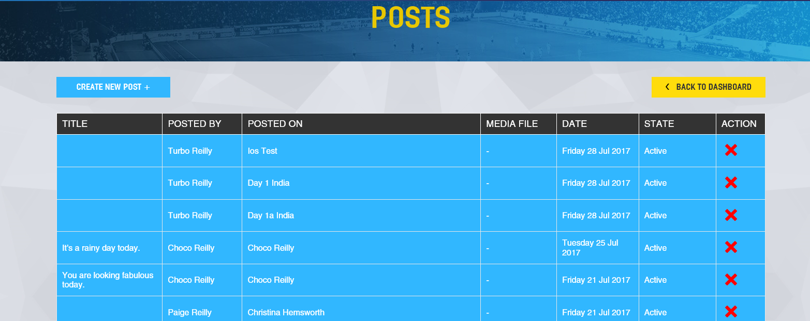

You can also create new posts on your player’s newsfeed. If you have more than one child you can either select “All” which will share your post on all of your children’s newsfeed or choose the child that you wish to post onto their newsfeed.

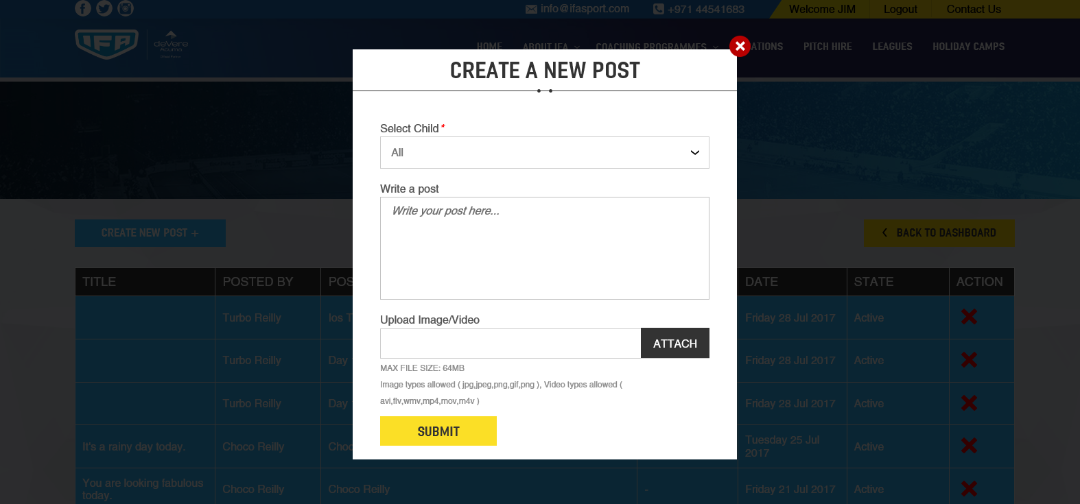

Contact Us
Simply fill in this form to send us a message.
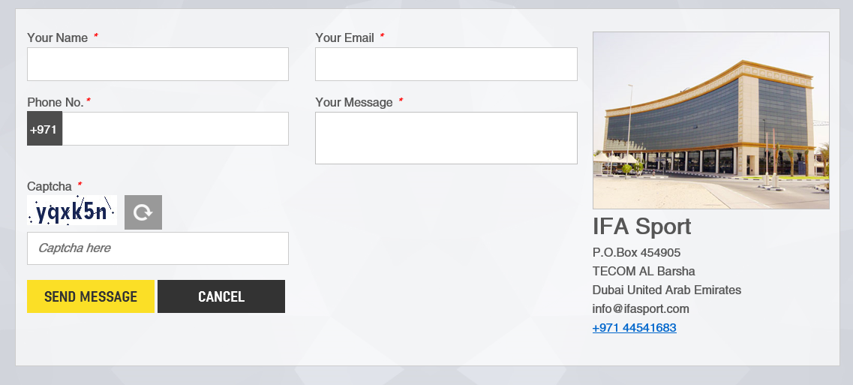

IFA Player Profile

This page will provide information that has been received or shared by coaches and friends, comments, posts and likes on your player’s page.

To access this page:

From the parent’s dashboard, select one of the players/child and click “Go to ________ News feed”
You can like and comment on posts and approve posts by clicking on the icons. Parental approval is required for all posts created by your child before being shared publicly. When clicking on Approve you will be asked to enter your password.

On the right side of the page are NEW features:-

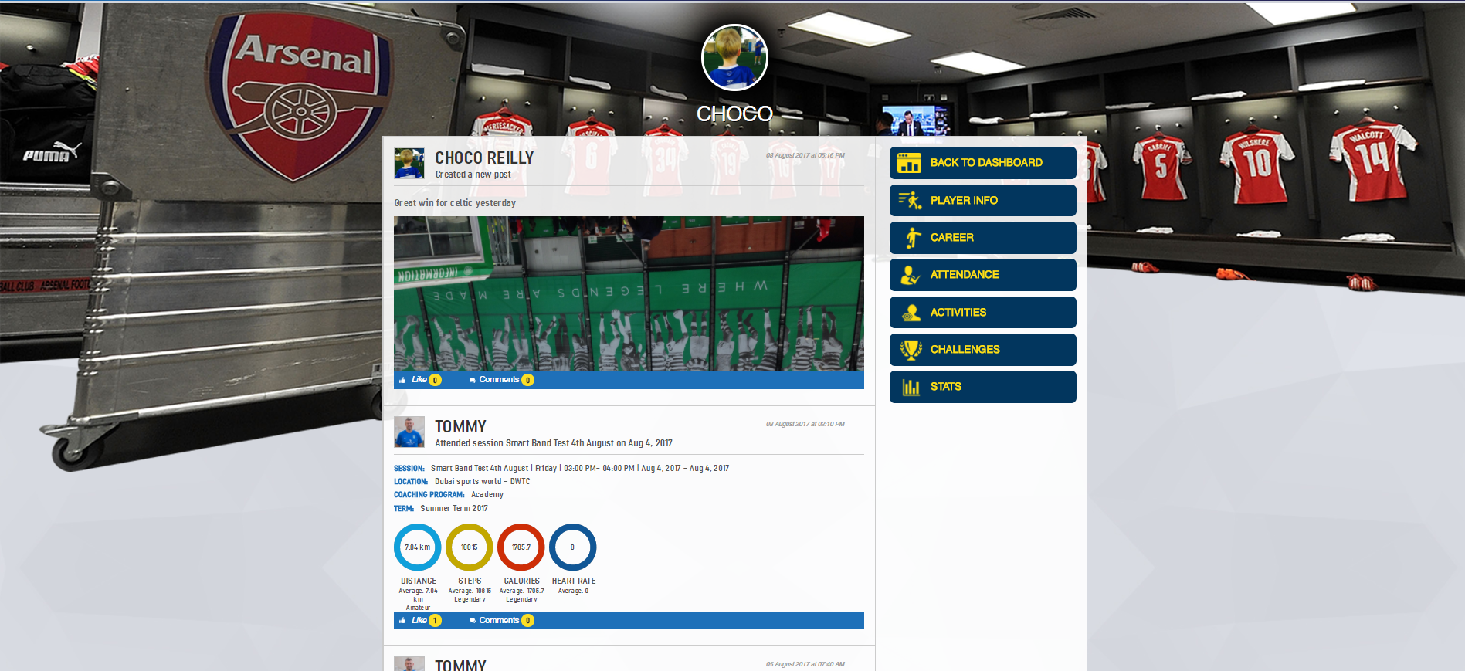

Player Info
Here you can see the profile of your child their friends and pictures and videos that they have posted.
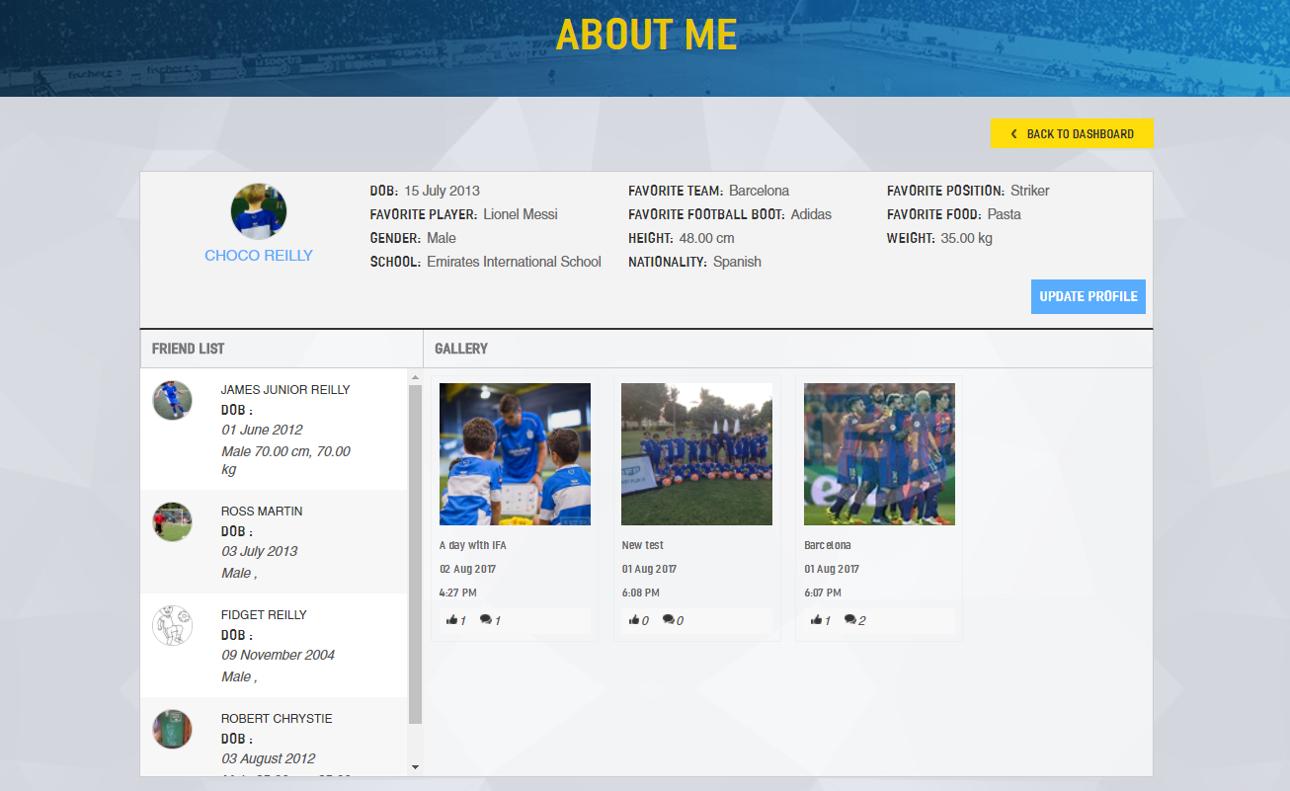

On the left hand side is the lists of all your child’s approved friends. Clicking on a friend on your child’s friend list you will see the profile of that child.

You can like or comment on their gallery pictures or videos by clicking on the like and comment icons which will take you to the screen below where you can see who has “liked” and “commented” on the picture or video. To add a comment select “comments” and then add your text below.

Career
This is a history of your child’s playing career since joining IFA. This will include assessment and performance reports (linked to the smart band) and challenges set be the coach.
Here you can approve challenges set by the coach and also like or comment on posts.

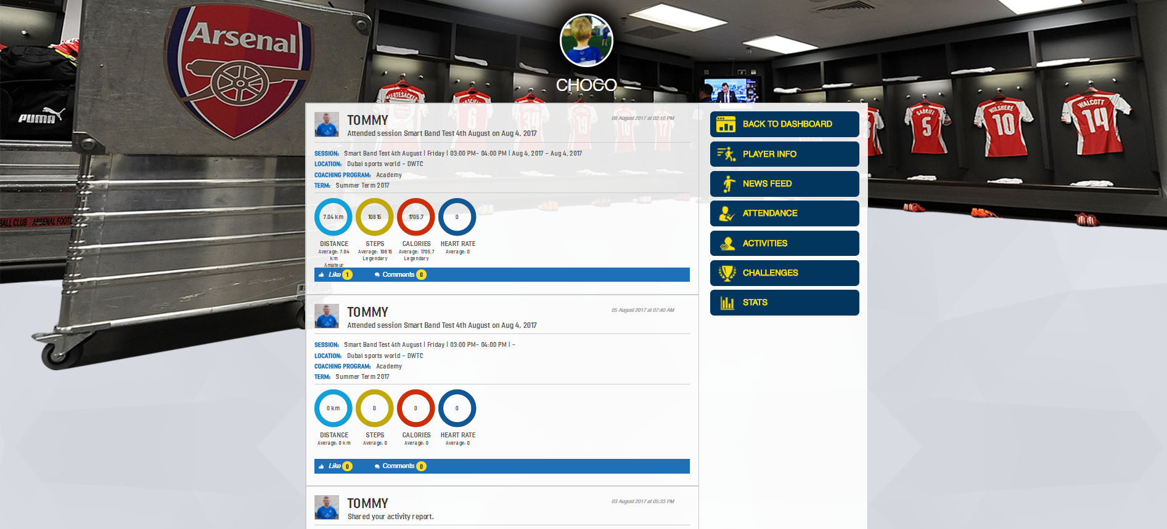

News Feed
Gives parents access to child’s IFA activities, posts created by child, friends or coaches. Shows everything that your child has done via the website/app.

Attendance
Shows details of the training sessions your child(ren) have taken part in.

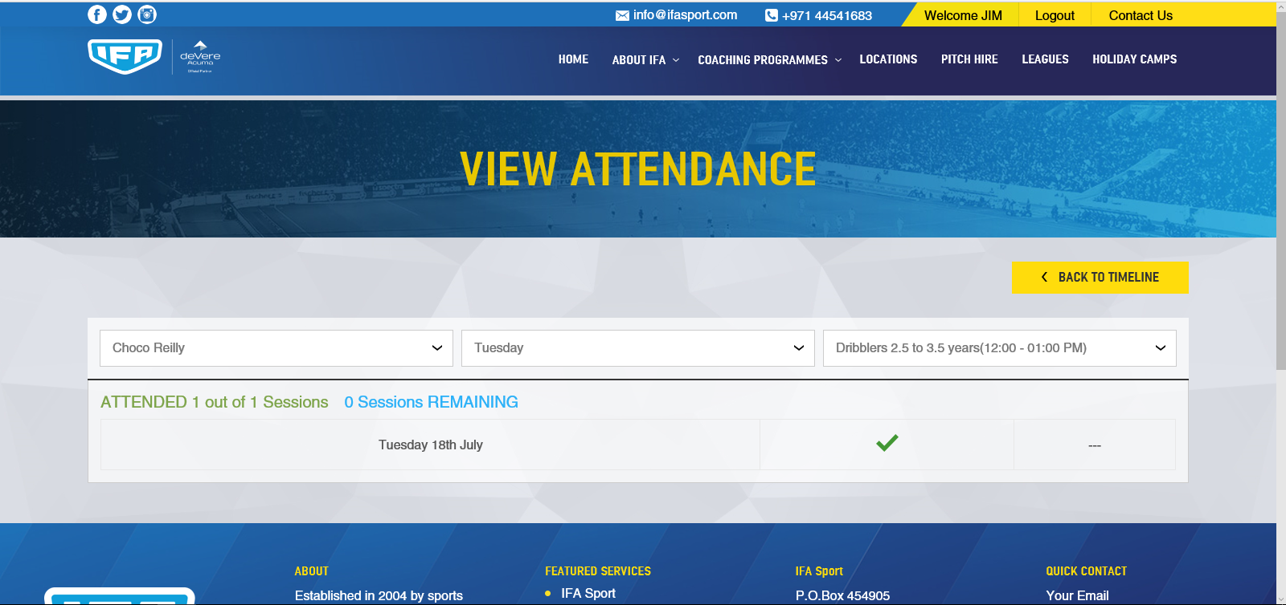

Challenges
Coaches will be able to set challenges for your child to do outside of their training session to help them improve and develop or to have some fun. Here you can see challenges accepted achieved and expired.

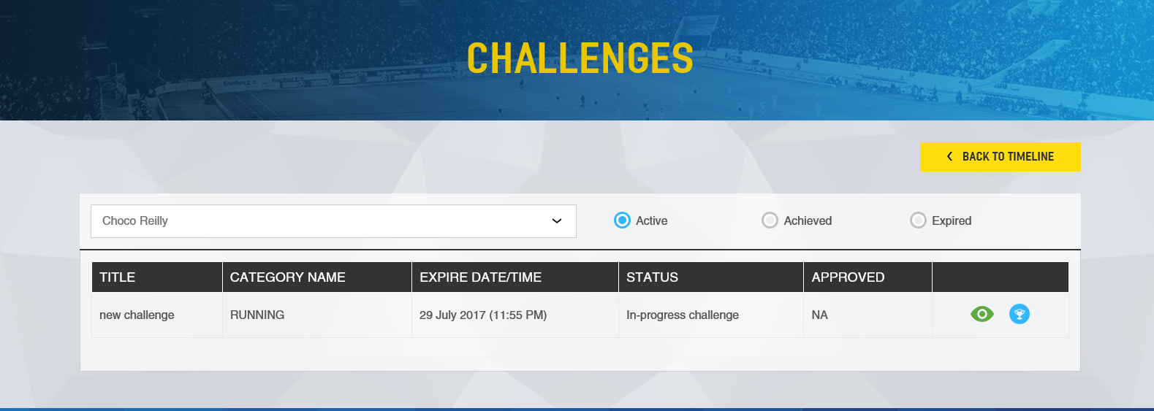

Clicking on the icon will show details of the challenge.
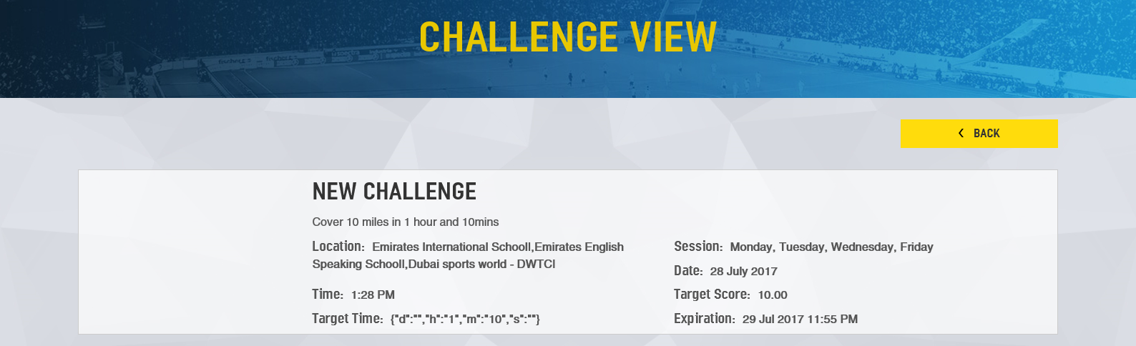
Clicking on the will show you the leader board for that particular challenge.
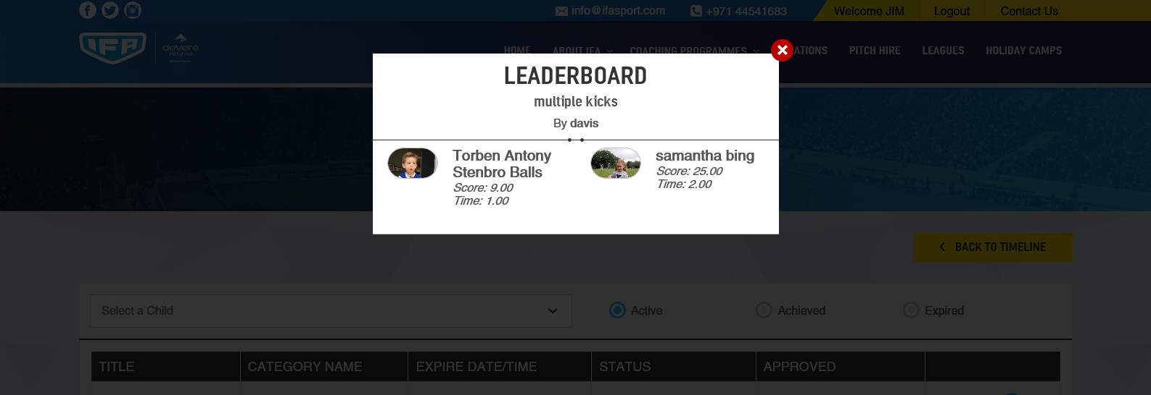

Stats
Coaches will assess your child’s performance and you can see the results here by clicking on “Score Report).

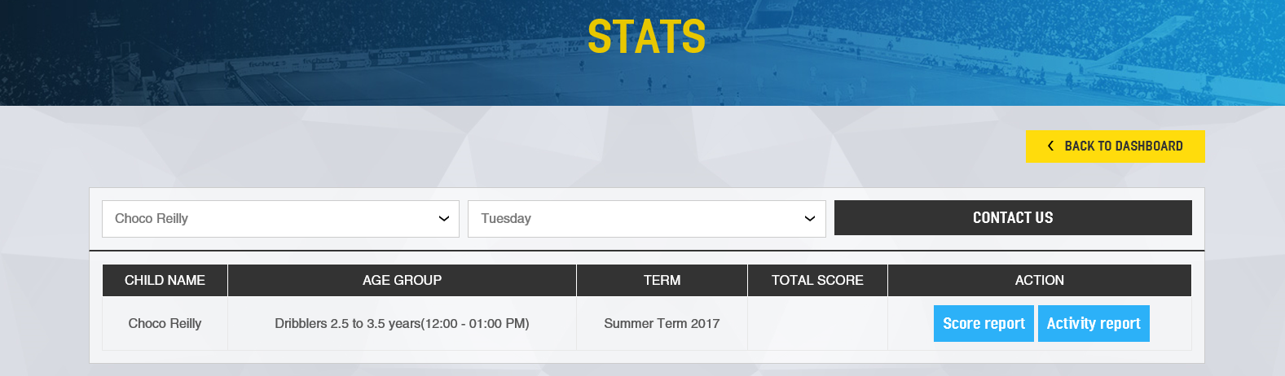

The report will also show comments from your child’s coach, set your child challenges to improve, and clicking on “My Training Plan” will show training videos for your child to watch and then practice the skill at home.
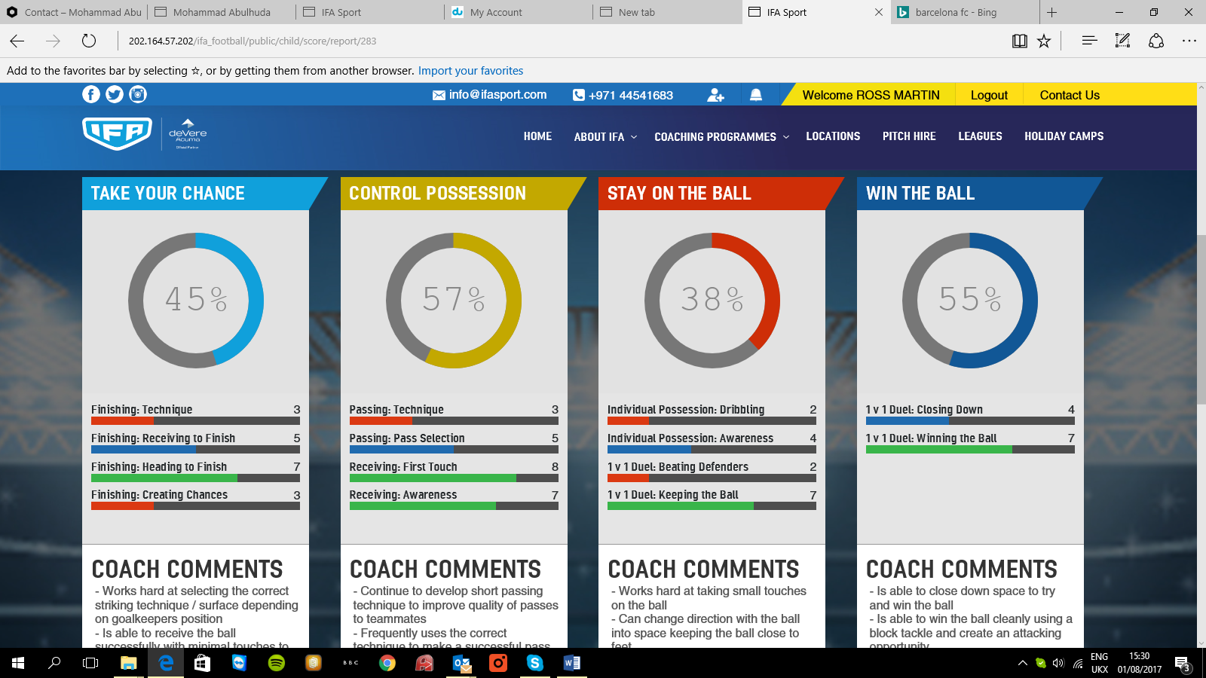

For every session your child has attends session you can view their performance which has been tracked by the Smart Band automatically by clicking on the “Activity Report”
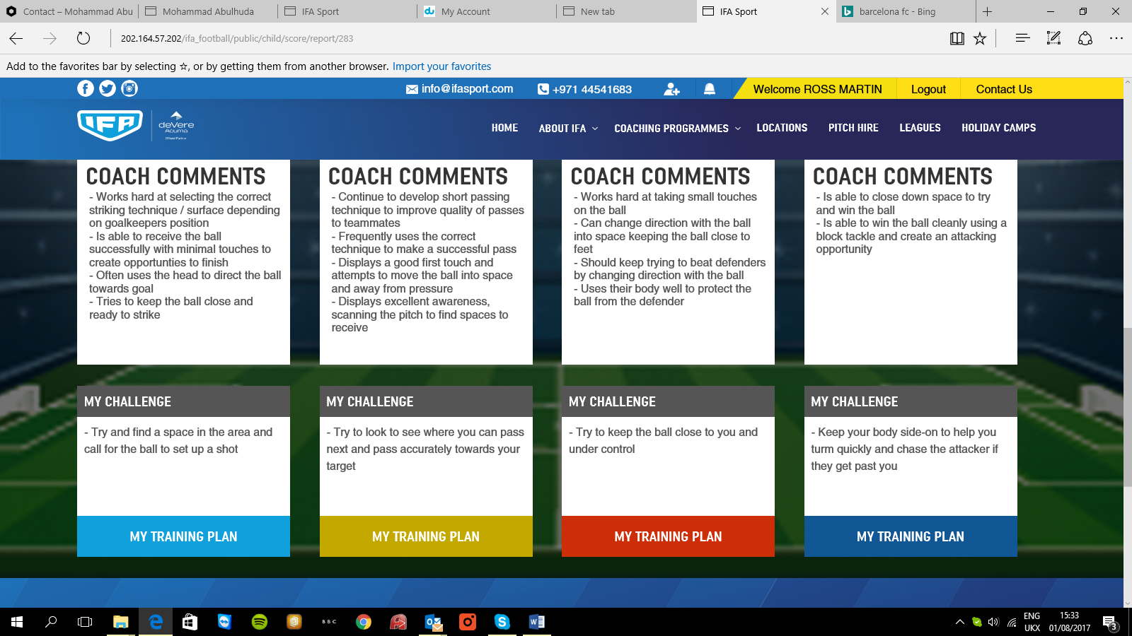

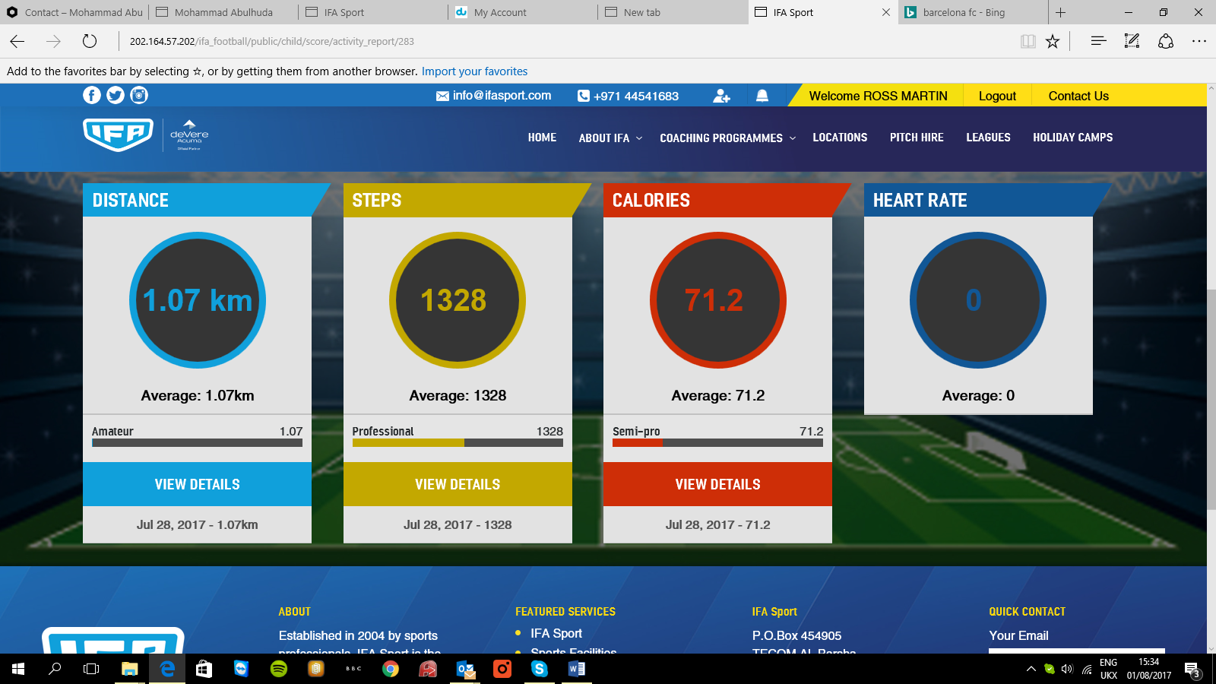

IFA Social Page

Childs Dashboard
On signing in with your user name and password you or your child will see the following screen. This is their newsfeed which shows all the activities of the child.
New friend requests or messages will be shown next to the icons at the top of the page.
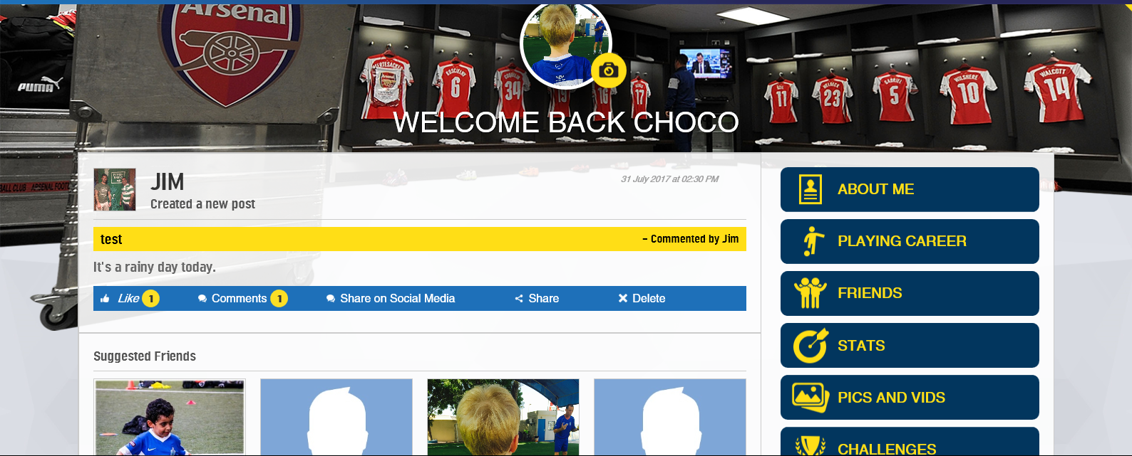
You can personalize this by uploading a profile picture by clicking on the camera icon or changing the background by clicking on the top right hand icon.
Your newsfeed includes “Suggested Friends” whose profile you can view by clicking on their pic. (We recommend that you know the person who you are sending a friend request to), posts, coaches’ challenges, activity and performance reports.
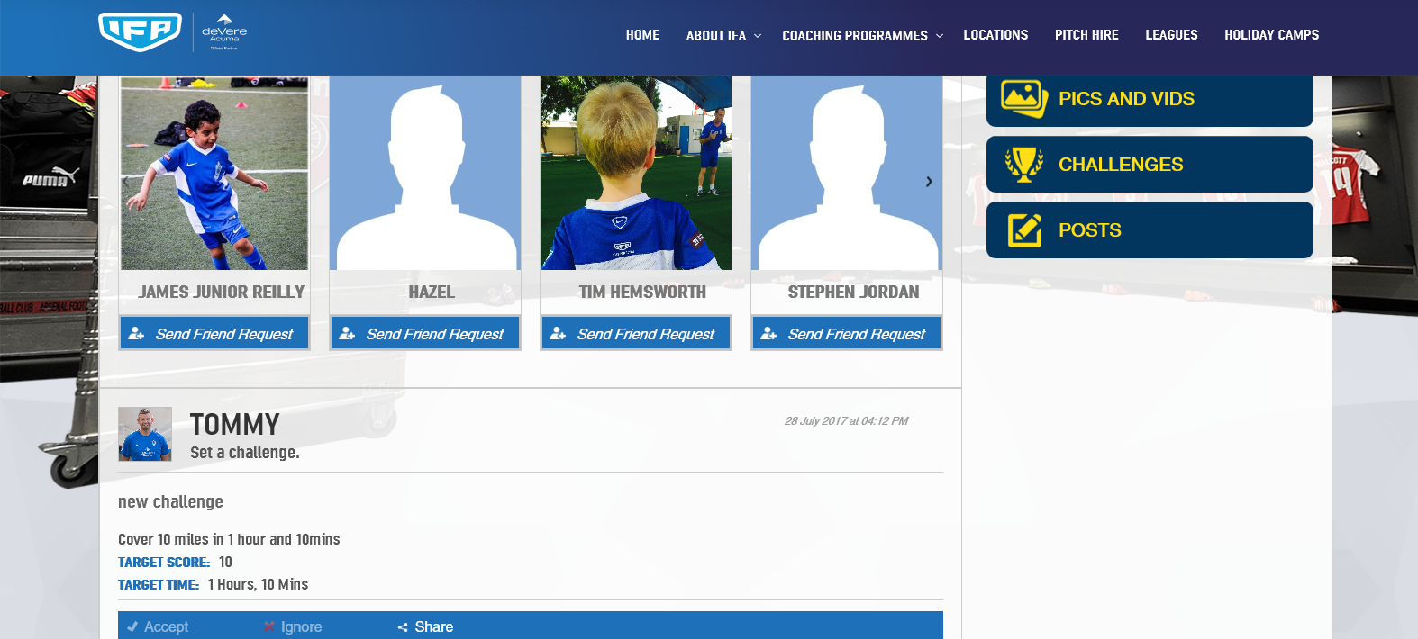
Click on a post to like, comment or share with friends, share on your Facebook or Twitter account or delete the post you can also accept a coach’s challenge.
By clicking on the like and comment icons which will take you to the screen below where you can see who has “liked” and “commented” on the picture or video. To add a comment select “comments” and then add your text below.

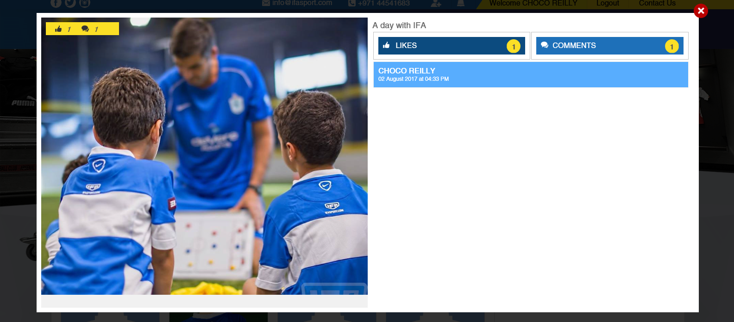

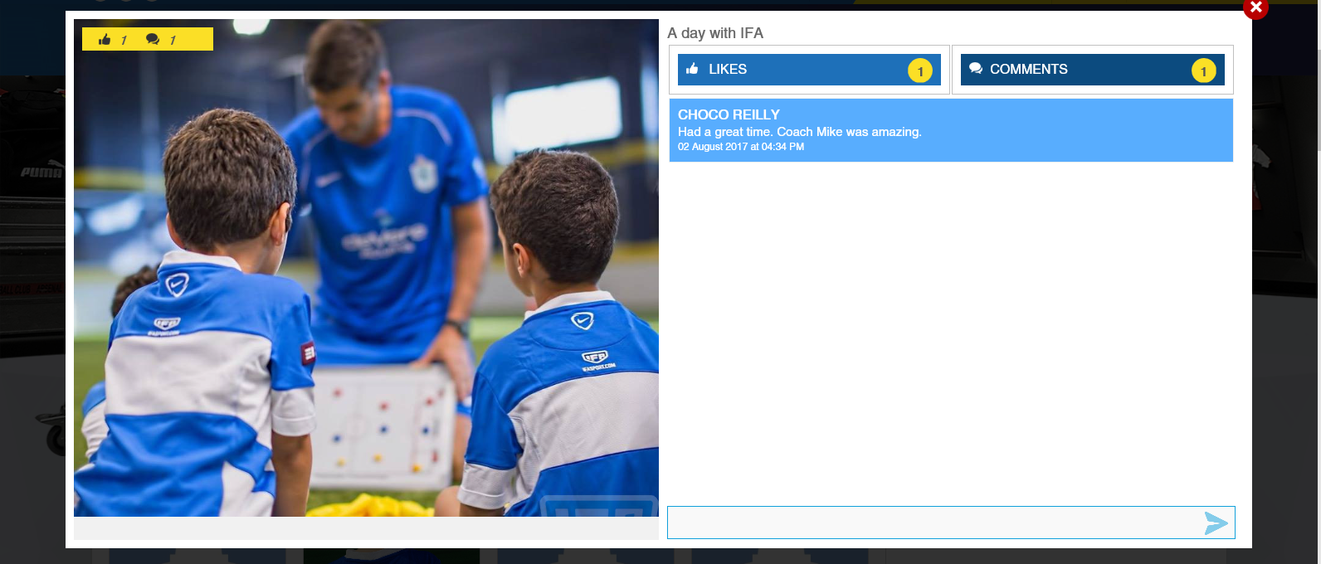

On the right hand of the screen you have a number of NEW options:-

About Me
Here you can update your profile. See your friends and pics and videos they have posted onto their timeline.
To update profile click on “Update Profile” then enter your details, you can then update the profile, go back and view your profile or cancel and changes made
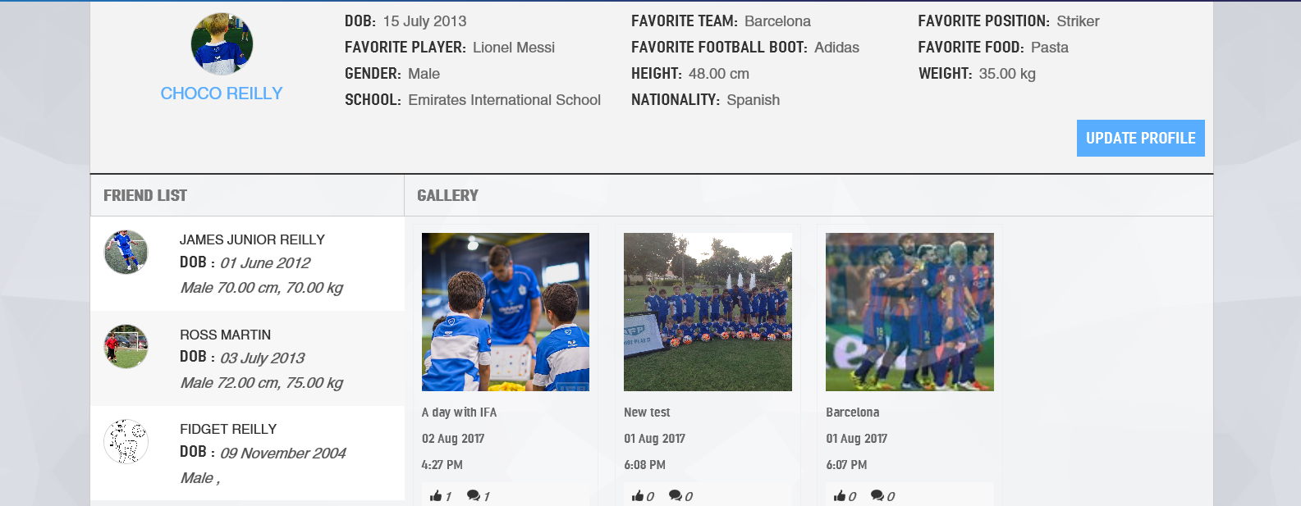
.
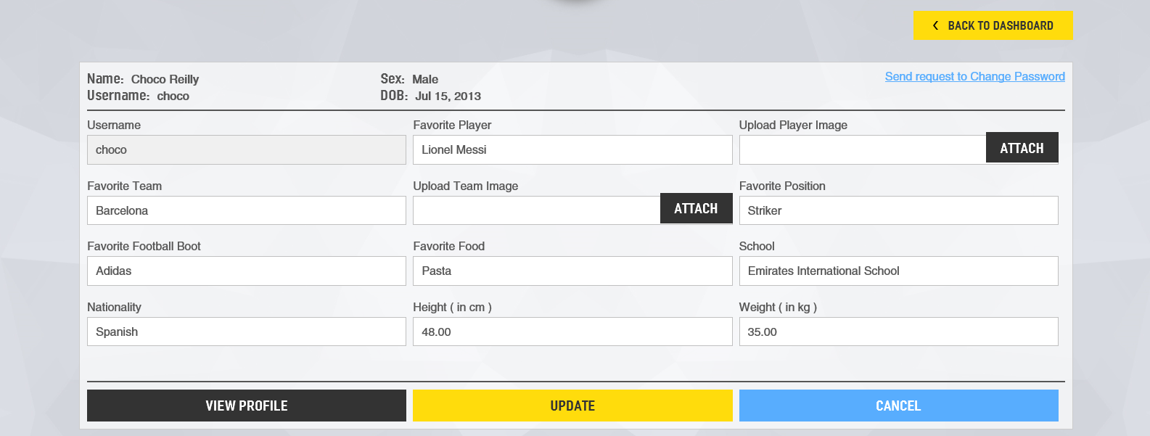
On clicking on a friend on your friend list you will see the profile of that friend. It will also show picture and videos in your gallery.

Playing Career
This is a history of your career since joining IFA. This will include assessment and performance reports (linked to the smart band) and challenges set be the coach. When you accept a challenge this will be shown in your “Challenges” area.
You can like, comment and share all of these with friends.

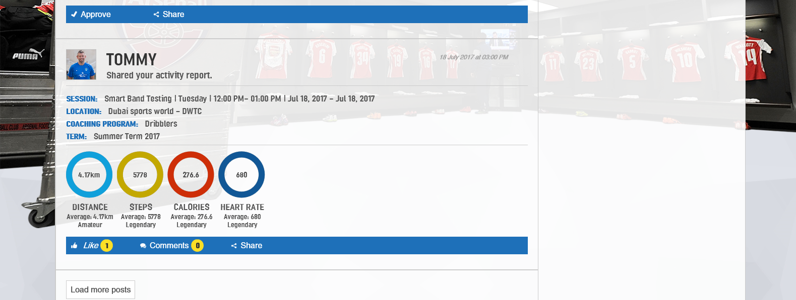

Friends
This will show a list of all friend added in the IFA Social Media Page. Here you can send a friend a message, view their profile, delete them or block them from contacting you.
Also you can see details of received or sent friend requests and approve or delete them and send requests to IFA players and their friends and family who are non IFA members.

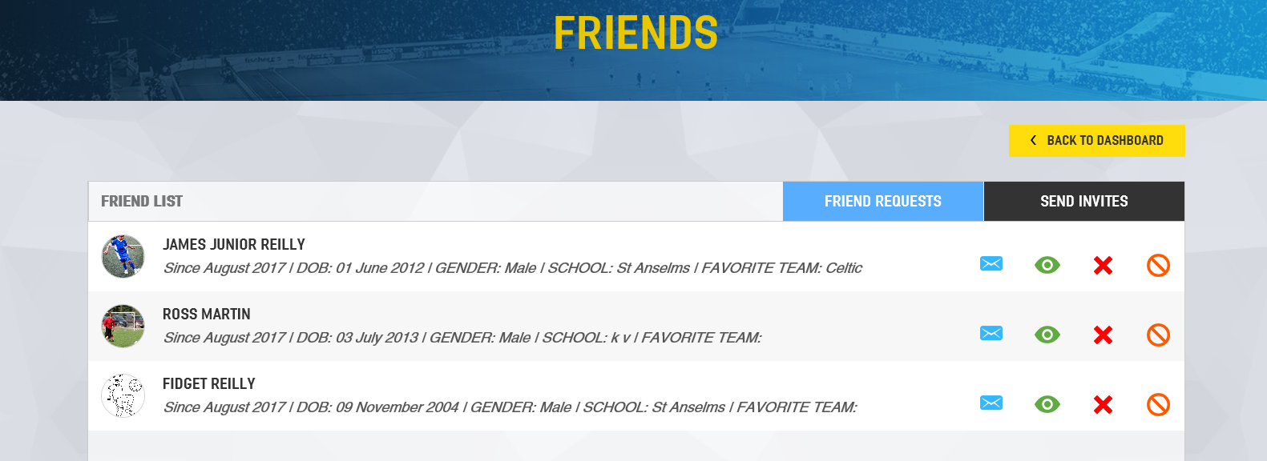

This screen shows a list of all friend. Here you can send a friend a message, view their profile, delete them or block them from contacting you.
To send a friend a message click on the icon.

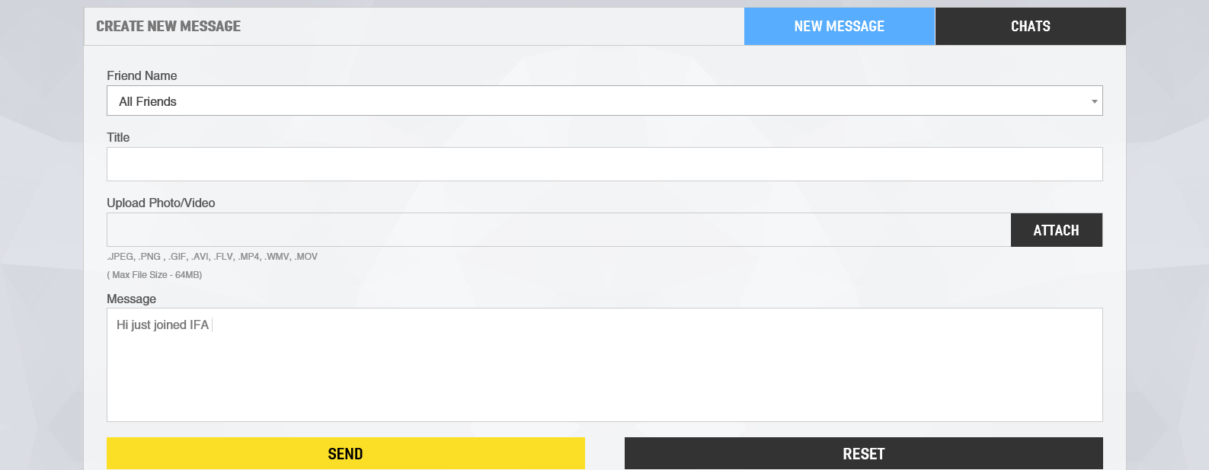

You can send a new message to all your friends or just one of them. Also here you can view chats with their friends by clicking on “Chats”

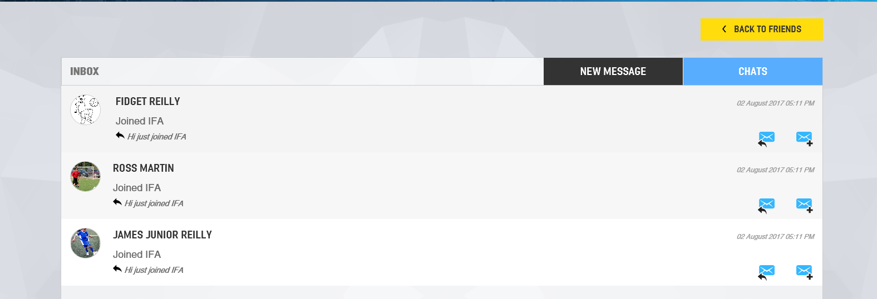
Here you can continue chatting with your friend or open a new conversation on a different topic.

Also you can see details of received or sent friend requests and approve or delete them and send requests to IFA players and their friends and family who are non IFA members.

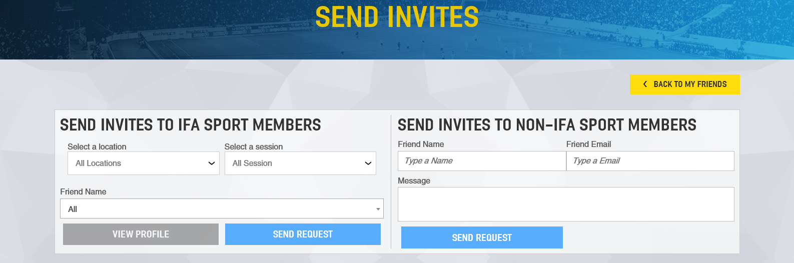

Stats
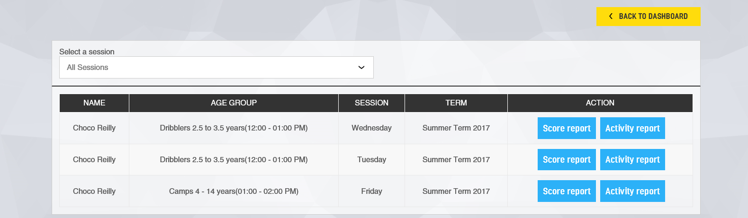

Coaches will assess your performance and you can see the results here by clicking on “Score Report)

The report will also show comments from your coach, set you challenges to improve, and clicking on Training Plan will show training videos.

For every session you attend you can view your performance which has been tracked by the Smart Band automatically by clicking on the “Activity Report”

Pics and Vids
You can view and upload new pics and vids here. Click on add new and fill in the Title, Description and Upload Image or video.
Choose Private if you do not wish this picture or video to be seen by anyone. If you select Public it will be shown on your Newsfeed and others can like or comment on it.

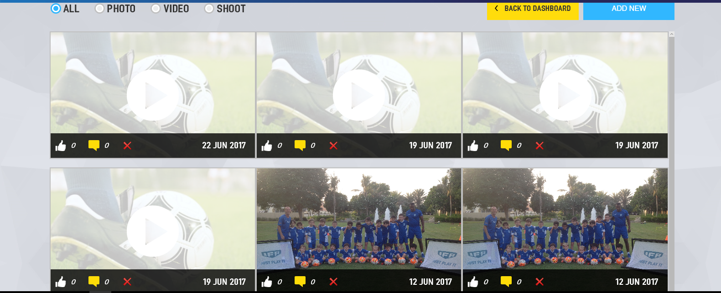

Challenges
Coaches will set challenges for your to do outside of your training session to help you improve and develop or just to have some fun. You can accept or ignore the challenge on your Newsfeed.

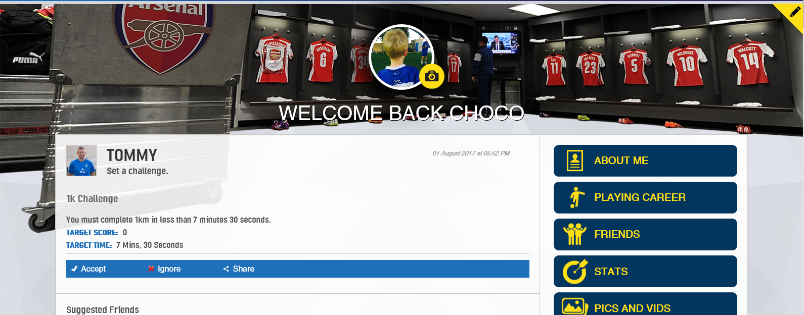

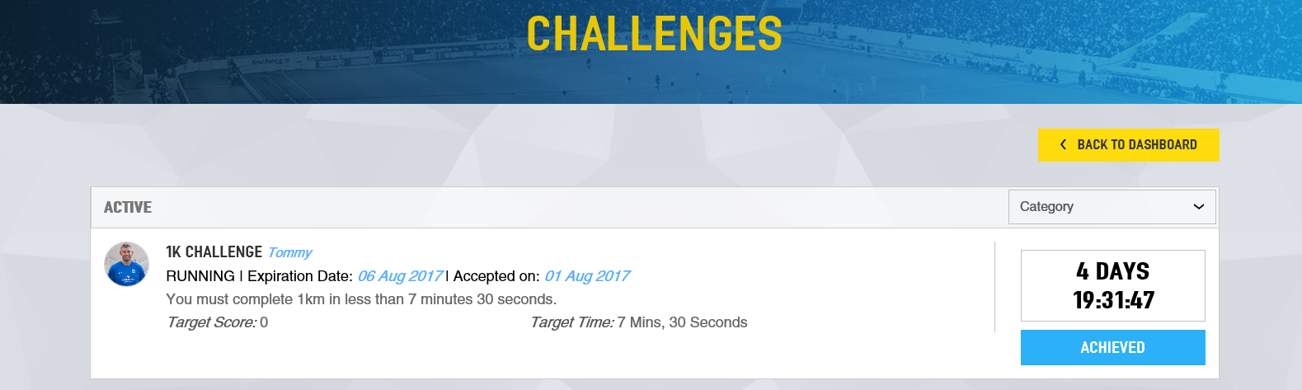

Here you can see challenges accepted achieved, not achieved and expired. If you have achieved the challenge then click on achieved and you will be asked to fill in your scores. You can upload a picture or video of you doing the challenge and add comments.
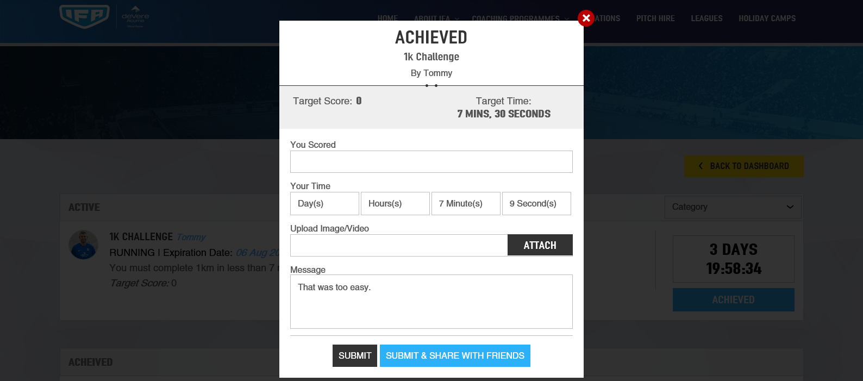

When you submit the challenge it may have to be approved by your coach or parent before it can be shown on the leader board.
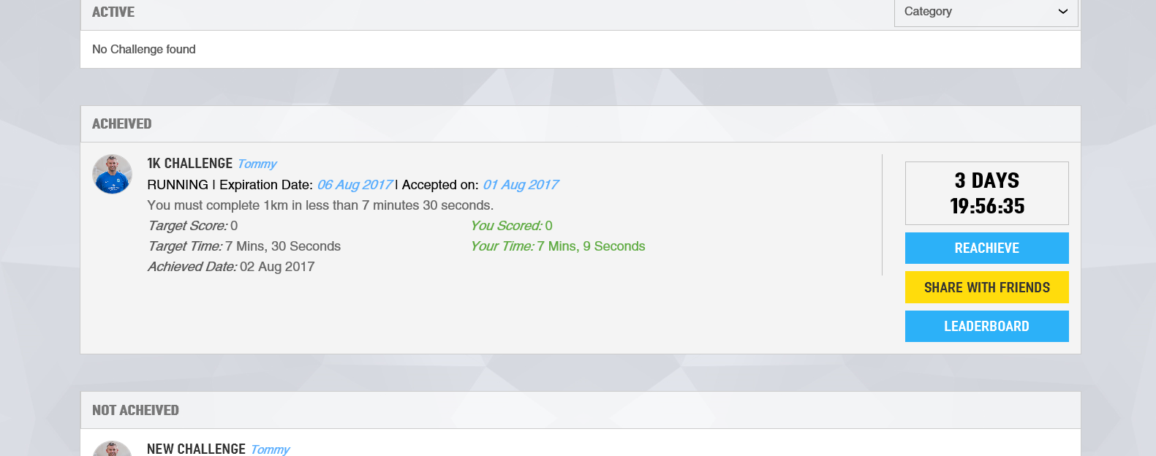

You can view the details of the challenge and the leader board for any particular challenge. You can also share the challenge with friends.
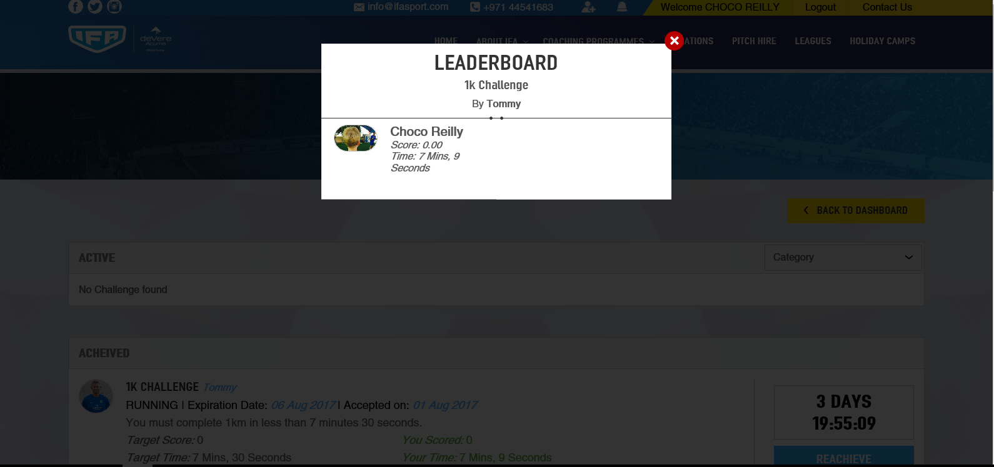

You can repeat the challenge at any time before it expires to try and better your time or performance so that you stay on top of the leader board.
Update your score by clicking on “Re Take Challenge”

Posts
Your can create posts and uploads pics and vids to share with friends. Your parent’s approval will be required before this is shown on your newsfeed.

